# Chapter III. is the Earth getting warmer?.

# UN Report: Last 10 Years Likely the Hottest Decade on Record



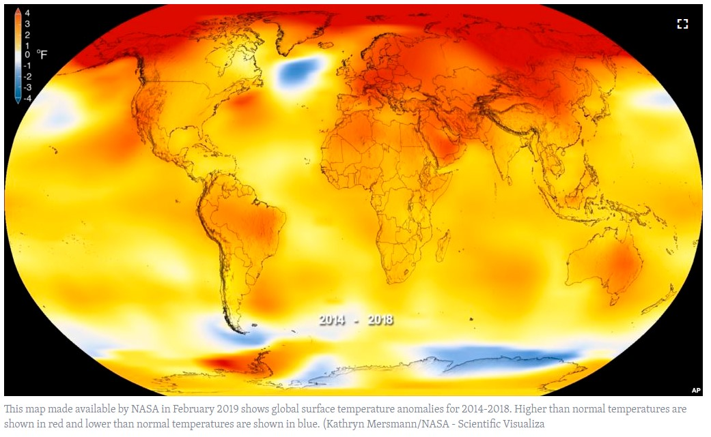

The United Nations weather agency says the past 10 years were likely the hottest **decade** since scientists began keeping records.

In a new report, the World Meteorological Organization, or WMO, blames the rising temperatures mainly on **greenhouse gases** produced by human activities.

“Average temperatures for the five-year, 2015-to-2019 and 10-year, 2010-to-2019 periods are almost **certain** to be the highest on record,” the WMO said.

The report predicted that 2019 would become the second- or third-warmest year on record. Final temperature measurements will not be available for several months.

Petteri Taalas is the Secretary-General of the WMO. He says severe heatwaves and floods that used to happen about once every hundred years have become “**regular**” events.

“Countries ranging from the Bahamas to Japan to Mozambique suffered the effect of **devastating** tropical cyclones. Wildfires swept through the Arctic and Australia,” he noted.

Taalas said that one of the main effects of climate change is the lack of predictable rainfall. This presents a threat to successful harvests and will likely create food security problems in some countries in the future, he said.

The report said climate change was a main driver of a recent increase in world hunger after 10 years of decrease. It estimated that about 820 million people suffered from hunger in 2018.

The WMO said that weather disasters have displaced millions of people this year and affected rainfall from India to northern Russia, to the central United States and other areas.

Oceans, which take in an estimated 90 percent of the extra heat produced by greenhouse gases, are now at their highest recorded temperatures. Sea water is also 25 percent more **acidic** than it was 150 years ago, the report said. This is threatening ocean environments that provide food and jobs for billions of people.

Levels of carbon dioxide in the atmosphere reached a record 407.8 parts per million in 2018 and continued to rise in 2019. Experts say carbon dioxide can be damaging because it can remain in the atmosphere for hundreds of years and in the ocean for even longer.

On Monday, at the opening of a climate meeting in Spain, United Nations Secretary-General Antonio Guterres warned that 400 parts per million had once been considered “unthinkable.” The UN Climate Change Conference brings together representatives from around the world to seek solutions to reduce greenhouse gas **emissions**.

Last year, the UN’s Intergovernmental Panel on Climate Change set a goal for countries to limit temperature increases to 1.5 Celsius or below. The group said this target could be reached by reducing greenhouse gases and restructuring the world economy to expand **renewable** energy sources.

The UN reported last week that the world needed to cut carbon emissions by 7.6 percent each year, every year, until 2030, to reach the 1.5 Celsius temperature goal.

The WMO’s Petteri Taalas urged the world to quickly launch steps aimed at reducing temperatures before it is too late. “If we do not take urgent climate action now, then we are heading for a temperature increase of more than 3°Celsius by the end of the century, with even more harmful **impacts** on human wellbeing,” he said.

I’m Bryan Lynn.

Bryan Lynn wrote this story for VOA Learning English, based on reports from Reuters, Agence France-Presse and the World Meteorological Organization. George Grow was the editor.

_____________________________________________________________

## **Words in This Story**

**decade**– n. any period of 10 years

**greenhouse gas**– n. gases in the atmosphere that trap heat

**certain**– adj. completely sure of something

**regular**– adj. happening repeatedly

**devastating**– adj. causing a lot of damage or destruction

**acidic**– adj. containing acid

**emission** – n. the act of releasing something

**renewable**– adj. any naturally occurring kind of energy, such sunlight or wind

**impact**– n. the effect that a person, event, or situation has on someone or something

_______________________