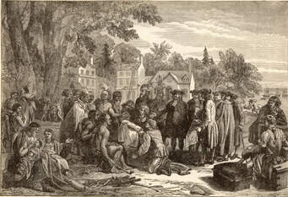

**THE NETHERLANDS IN THE NEW WORLD**

Long ruled by Spain, the Dutch rebelled in 1581 and declare their independence. Being great traders, they took steps to obtain a share of the rich far Eastern trade. A group of merchants hired **Henry Hudson**, an English navigator, to find a new water route to the Indies. In his vessel, the *half moon*, Hudson explored the North American coast from Maine to California, becoming the first European to discover the Hudson River (1609). He sailed up the river to what is nowadays Albany.

**The Dutch Settle New Netherland:**

As a result of Hudson’s voyage, the Dutch claimed the area from the Hudson River Valley southward to Delaware Bay. They called this region *New Netherland*. In 1614 Dutch merchants established a fur trading post near Albany. Ten years later 30 families came to New Netherland. They were sent by the Dutch West India Company, to which the Dutch government had granted exclusive trading and colonizing rights in the New World. Most of settlers went up the Hudson River to the area of the first Dutch trading post, where they founded *Fort Orange*.

Within the next two years, additional colonists arrived. Many of them settled in New York Bay and on the lower Delaware River. A large settlement was made on Manhattan Island. This town, named *New Amsterdam*, soon became the seat of government and main trading center of New Netherland.

**The Dutch Adopt the Patron System**:

To encourage settlement, the Dutch West India Company offered the title of *patroon* and a large estate to anyone who would bring in 50 adults and settle them as tenants on his land. The patroon would supply his tenants with homes, cattle, and tools. In return the tenants would give him part of their produce.

**The Netherland’s Legacy to America:**

**1. Architecture:** many dwellings, particularly in New York State, reflect the Dutch architectural influence to this day.

**2. Place-Names:** Many place-names in New York State (Catskill, Brooklyn, Yonkers, Bowery, and Tappan Zee) are derived from the Dutch.

**3. Sports:** Two popular sports – bowling and ice skating- were introduced into the New World by the Dutch.

**4. Famous people:** Three presidents of the United States- Martin Van Buren, Theodore Roosevelt, and Franklin D. Roosevelt**-** were descendants of early Dutch settlers.