**Instructor:** Elfergougui Wissam

**Module:** foreign language **(English)**

**TD/Class:** 3rd year

**The Basic elements for a successful writing**

1. **Sentence Structure**

**Sentence Fragments and Complete Sentences**

A sentence must have a subject and a verb. A sentence must also be a complete thought.

• A subject is a person, place, or thing. It names who or what the sentence is about.

The subject does the action of the verb.

•A verb is either an action word that tells the reader what is happening or a state of being word (be, am, is, are, was, were).

A phrase fragment is missing either a subject or verb or both and is not a complete thought.

A dependent clause fragment looks like a complete sentence because it has a subject and a verb. However, it is introduced by a subordinating conjunction (after, although, as, because, how, even if, since, that, unless, until, when, while, what).

• The subordinating conjunction makes the clause incomplete; that is, the clause does not express a complete thought.

Example: The student handed the homework

This word group has a subject (The student) and an action verb (handed). It also expresses a complete thought. It is a complete sentence.

Example: Sit down! Hurry up!

Although these word groups look like fragments because they appear to have no subject, these are examples of imperative sentences. Imperative sentences give a command. The subject of imperative sentences is actually understood to be you.

IN REVIEW, a complete sentence must pass this simple test:

•Does it have a subject?

• Does it have a verb?

•Does it express a complete thought (idea)?

**2. Paragraph Writing**

**A - Topic Sentences**

A topic sentence is the most important sentence in a paragraph. Sometimes it is referred to as a focus sentence. It helps organize the paragraph by summarizing the information in the paragraph. The topic sentence is usually the first sentence in a paragraph (although it doesn't have to be).

Eg: There are many reasons why pollution in India is the worst in the world.

From this sentence we understand that the paragraph will be about the reasons of pollution in India.

**B-Transition words**

Transition words and phrases, also called linking or connecting words, are used to link together different ideas in the text. They help the reader to follow the arguments by expressing the relationships between different sentences or parts of a sentence.

The following table shows some frequently used transition word:

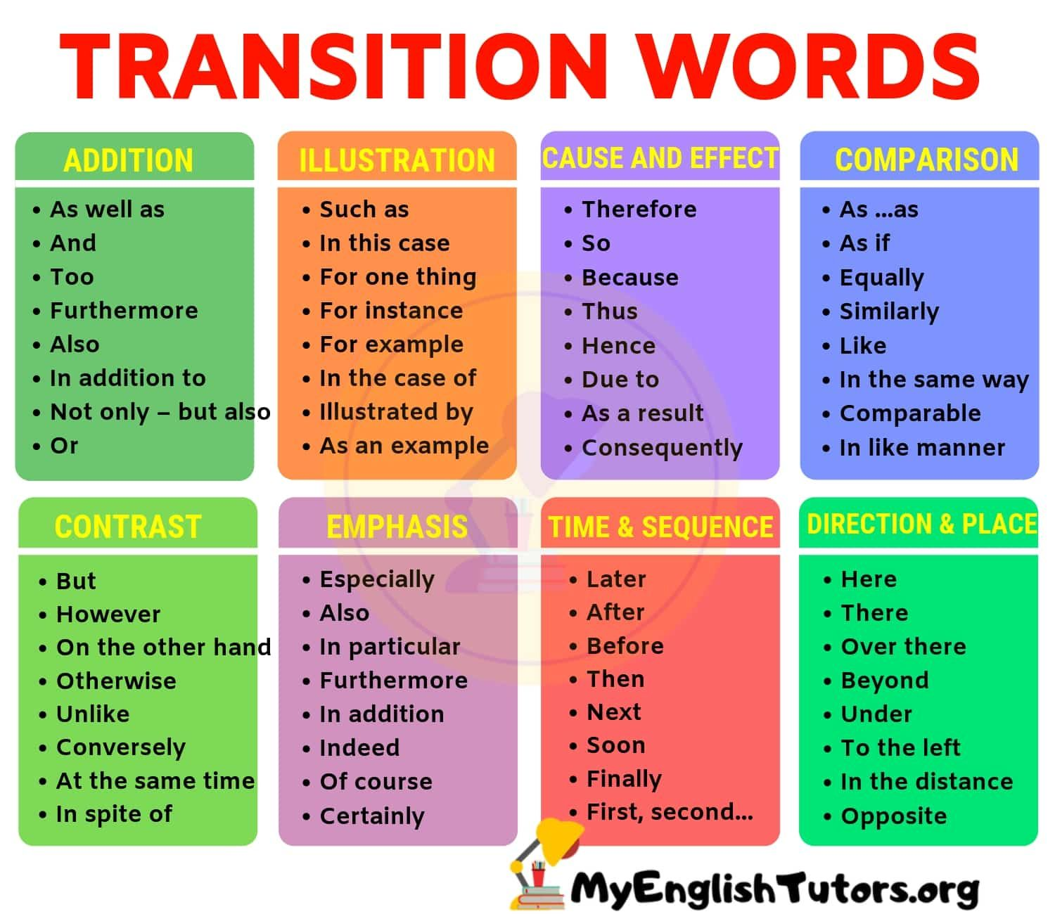

**C- Concluding sentence:**

A closing sentence or the concluding sentence; Every paragraph needs an ending. It closes the door to the paragraph. It summarizes the main ideas of a paragraph. It is not a relevant detail or a new idea. It restates the topic sentence.