**Chapter II : COAL AND PETROLEUM**

***Course 02: Petroleum***

You know that petrol is used as a fuel in light automobiles such as motor cycles/ scooters and cars. Heavy motor vehicles like trucks and tractors run on diesel. Petrol and diesel are obtained from a natural resource called petroleum. The word petroleum is derived from petra (rock) and oleum (oil) as it is mined from between the rocks under Earth as shown in Fig. 5.4.

Do you know how petroleum is formed?

Petroleum was formed from organisms living in the sea. As these organisms died, their bodies settled at the bottom of the sea and got covered with layers of sand and clay. Over millions of years, absence of air, high temperature and high pressure transformed the dead organisms into petroleum and natural gas. Look at Fig.4. It shows the deposits of petroleum and natural gas. You see that the layer containing petroleum oil and gas is above that of water. Why is it so? Recall that oil and gas are lighter than water and do not mix with it.

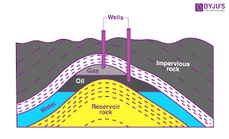

**Fig.4** : Petroleum and natural gas deposits.

1. **Refining of Petroleum**

Petroleum is a dark oily liquid. It has an unpleasant odour. It is a mixture of various constituents such as petroleum gas, petrol, diesel, lubricating oil, paraffin wax, etc. The process of separating the various constituents/ fractions of petroleum is known as refining. It is carried out in a petroleum refinery (Fig.5)

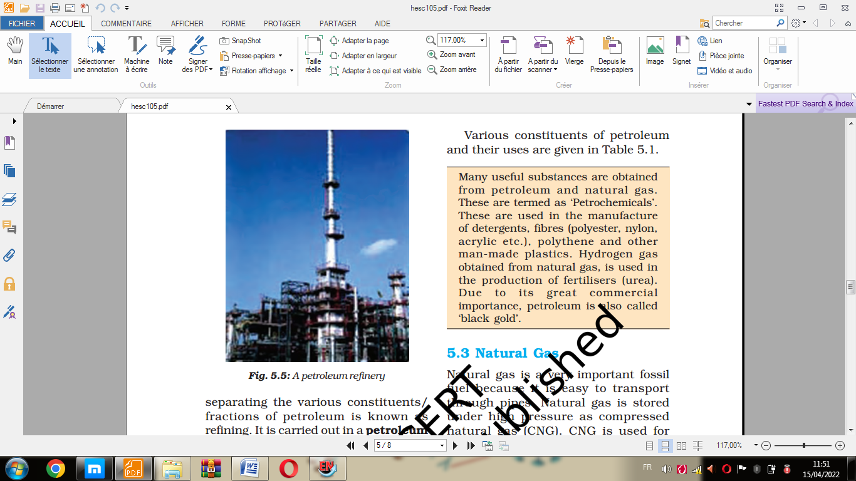

**Fig.5** : A petroleum refinery

Various constituents of petroleum and their uses are given in **Table** .1

**Table.1** Various Constituents of Petroleum and their Uses.

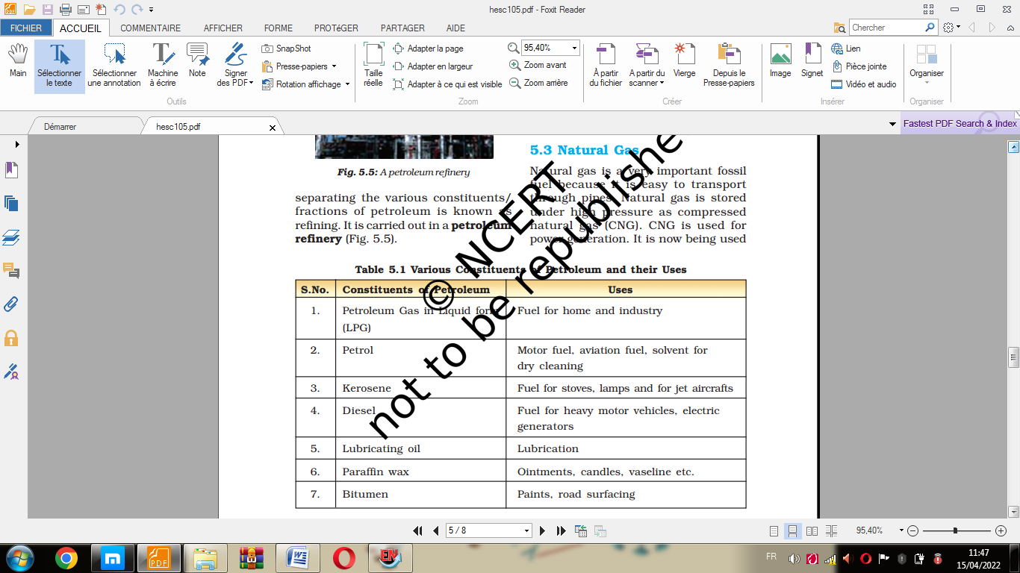

Many useful substances are obtained from petroleum and natural gas. These are termed as ‘Petrochemicals’. These are used in the manufacture of detergents, fibres (polyester, nylon, acrylic etc.), polythene and other man-made plastics. Hydrogen gas obtained from natural gas, is used in the production of fertilisers (urea). Due to its great commercial importance, petroleum is also called ‘black gold’.