**Chapter IV: Laboratory Equipment**

**(Glassware and Preparatory Equipments)**

**Learning Objectives**

1. List the various types of glassware used in a laboratory and explain the use of each.
2. List the various types of preparatory equipment and explain the use of each.
3. **Glassware**

One of the things that impress most students the first time they enter an analytical laboratory is the many different types of glassware that are used. Each piece of glassware is constructed to be used for a particular purpose. The following are some common pieces of glassware found in an analytical laboratory:

**Beaker**

* A beaker is the most common of all laboratory glassware.
* Beakers come in many different volumes and are used primarily to mix chemicals.
* Beakers should not be used to measure accurate volumes.

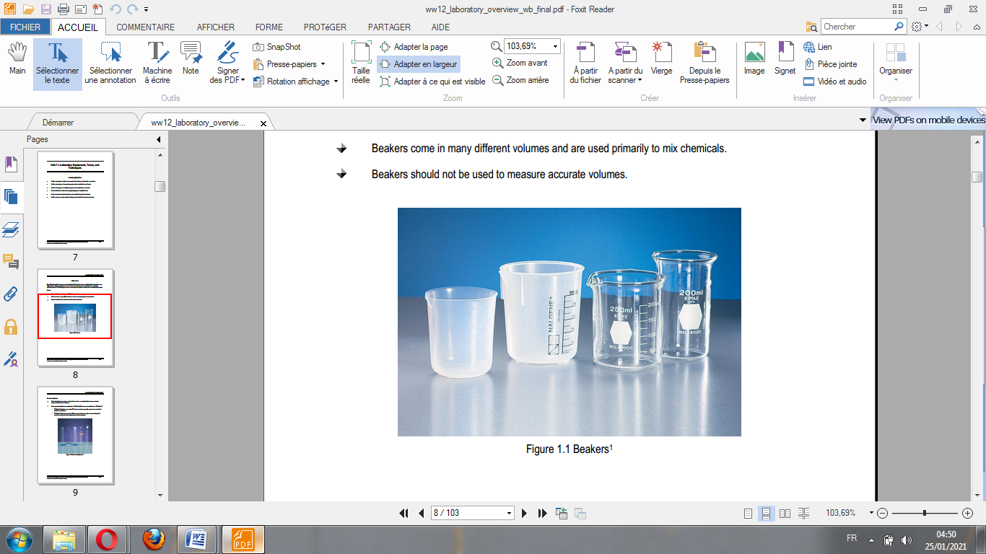

**Figure 1.1** Beakers.

**Graduated Cylinder**

* Graduated cylinders come in a variety of sizes and are used primarily to measure accurate volumes of chemicals or solutions.
* Some graduated cylinders are calibrated as “To Contain” and some are calibrated as “To Deliver.”
* “To Contain” cylinders are marked TC and are used to accurately measure how much of a liquid is in a container.
* “To Deliver” cylinders are marked TD and are used to measure the amount of liquid that needs to be poured from the cylinder into another container.

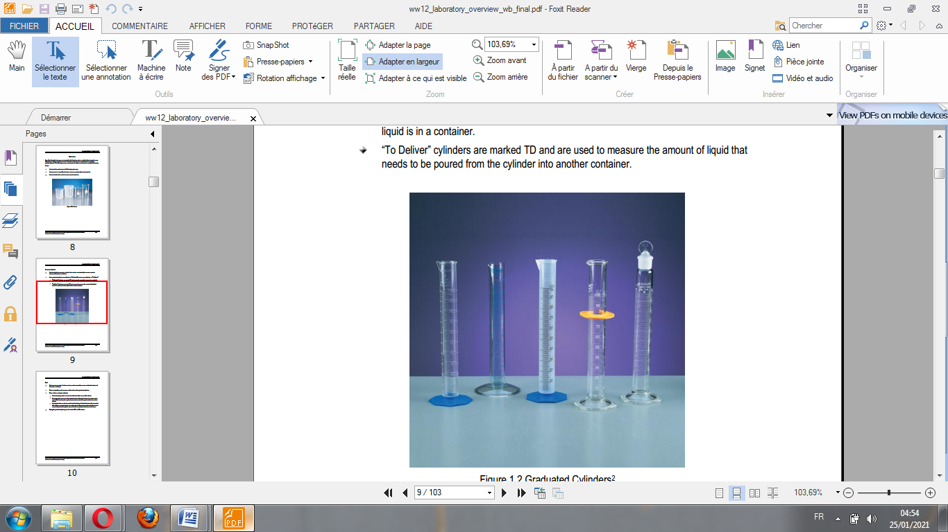

**Figure 1.2** Graduated Cylinders.

**Pipet**

* Pipets come in a variety of volumes and are used to accurately measure and transfer volumes of chemicals or solutions.
* Pipets are typically used to measure smaller volumes than graduated cylinders.
* There are three main types of pipets:
* Volumetric pipets, which are made to contain and deliver one specific volume.
* Graduated pipets can be used to transfer fractions of their total volume. A graduated pipet can be filled and drained to any level marked on the side of the pipet to deliver the desired volume.
* Serological pipets can also be used to transfer fractions of their total volume. It is somewhat different from a graduated pipet. A serologic pipet is filled only up to the level of the desired amount of liquid and the pipet is allowed to drain completely to deliver the total volume.
* Pipets, like graduated cylinders, are also made in TC and TD versions.

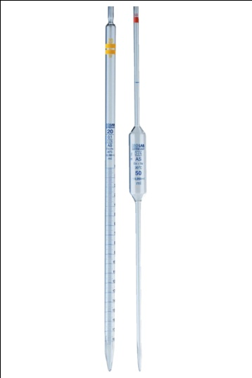

**Figure1.3** Graduated & volumetric glass pipettes.

**Buret**

* Burets are available in a variety of volumes and are used to accurately deliver volumes of solutions.
* **Burets are similar to pipets, but the difference is that burets have a valve at the bottom of the cylinder that can be used to add very minute and precise volumes of a solution. These valves are referred to as stop-cocks.**
* Burets are typically used to conduct an analytical procedure known as titration.

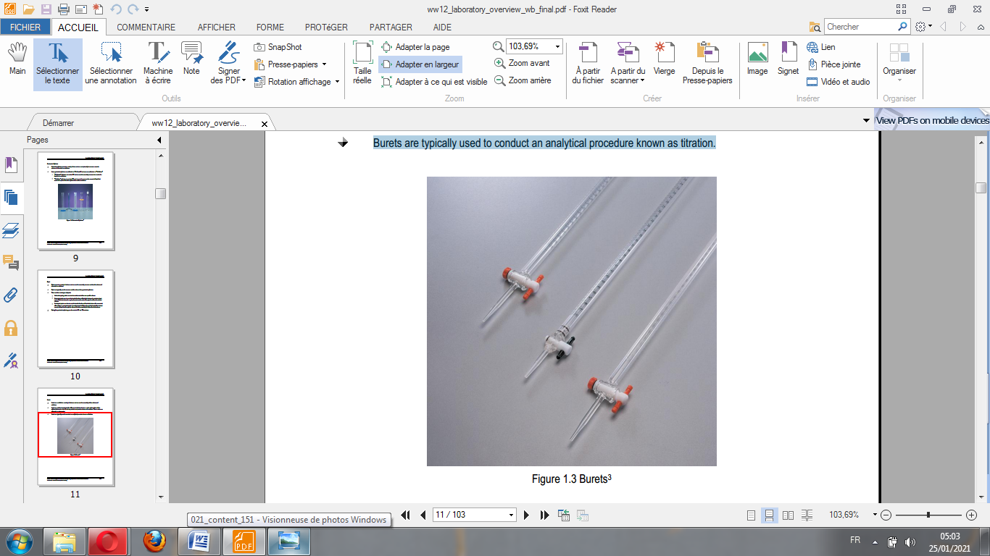

**Figure 1.4** Burets.

**Flask**

Many different types of flasks are used in an analytical laboratory.

They come in a number of volumes and are typically used to store or mix chemicals or to conduct chemical reactions such as digestion.

The most common type of flask is known as an Erlenmeyer flask.

Another common type of flask is a volumetric flask, which is made to contain a very precise amount of chemical. Volumetric flasks are usually used to prepare standard solutions.

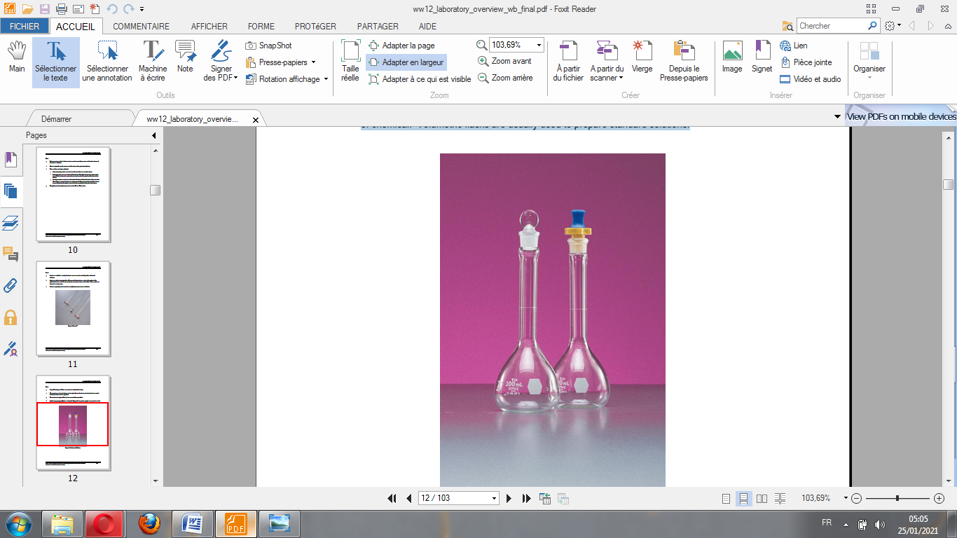

**Figure 1.5** Volumetric Flasks.

**Bottle**

* Bottles have three primary uses:
* To store chemicals or solutions.
* To collect samples.
* To conduct analyses.
* Reagent bottles are typically used to store chemicals.
* A Biological Oxygen Demand (BOD) bottle is used to conduct BOD analyses and has a “ground glass” stopper fitting. This stopper allows the bottle to be filled completely and forms an air tight seal so that no oxygen can enter the bottle during the 5 day BOD incubation

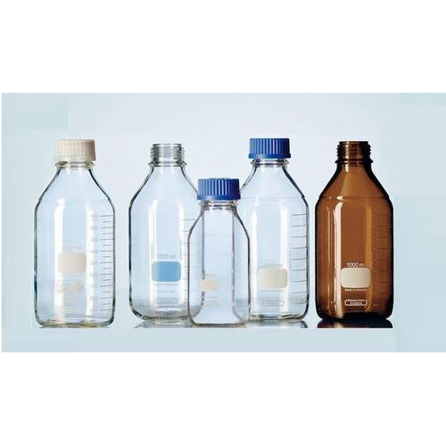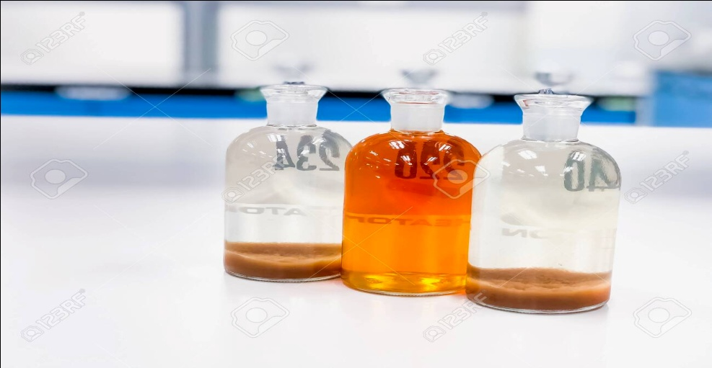

**Figure 1.6** Laboratory Glass Bottles ( left), BOD bottles ( Right).

**Funnel**

* Funnels are used to transfer liquid or solid chemicals from one container to another.
* Filter paper can be used with a funnel to separate solids from a liquid.
* There are two specialty types of funnels:
* A Buchner funnel contains a perforated plate in the bottom and is used with a filter flask and a vacuum to separate solids from a mixture.
* A separatory funnel is used to separate two chemical mixtures, of different densities, from one another. The chemical mixtures are added to the separatory funnel and the heavier mixture sinks to the bottom of the funnel. The funnel has a stop-cock which, after the mixtures have been separated, is opened, allowing the heavier mixture to drain off the bottom.

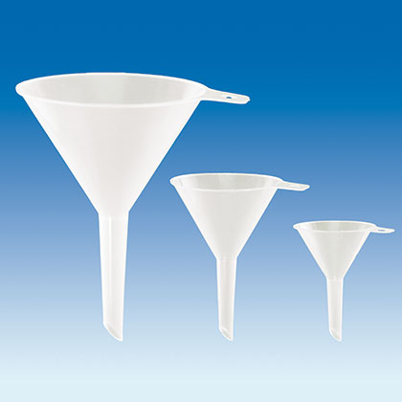

**Figure 1.7** Funnels.

**Test Tube**

* Test tubes are used to contain or mix small quantities of chemicals.
* They are primarily used for bacterial testing.
* Nessler tubes are used for colorimetric analyses using a color comparator.

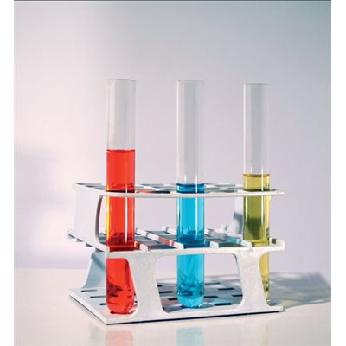

**Figure 1.8** Test tubes.

**Imhoff Cone**

* An Imhoff cone is used to conduct sludge volume analyses.
* A known volume of sludge is added to the cone and the solids are allowed to settle. Then a determination of volume of solids compared to total volume can be made.

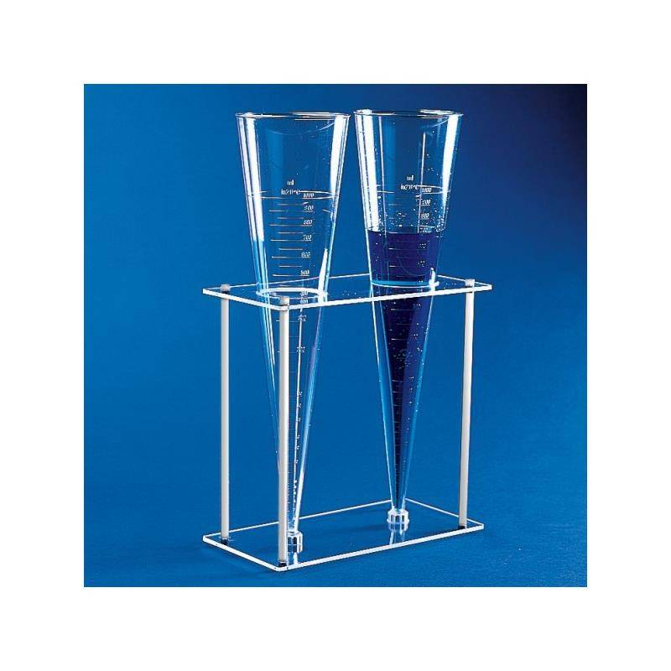

**Figure 1.9** Imhoff Cone.

**Condenser**

* A condenser is used as part of a distillation.
* Cold water is circulated through the condenser, which causes the vapor produced during the distillation to recondense to a liquid. The liquid is then collected and analyzed.

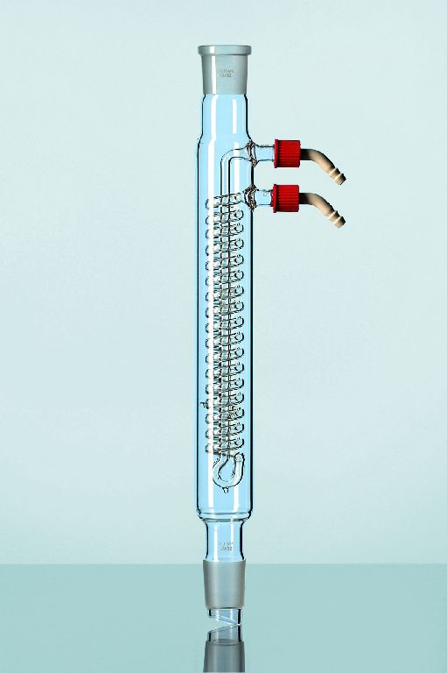

**Figure 1.10** Condenser.

**Petri Dish**

Petri dishes are used primarily for bacterial analyses. They are available in a variety of sizes and can have either a loose or tight fitting lid.

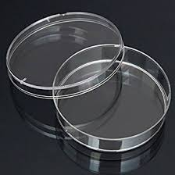

**Figure 1.11** Petri Dish.

1. **Preparatory Equipment, Incubators, Miscellaneous Equipment**

Many laboratory analyses can not be conducted on samples as they are collected. The samples must be prepared prior to analysis. Preparation may be as simple as filtering the sample to remove solid material or as involved as adding acid to the sample and boiling it during a process known as digestion. The purpose of these preparatory steps is to convert the substances in the sample for which analysis is desired to a state that is detectable by the instrumentation you are using or to remove substances which may interfere with the detection of the target substance.

**Burner**

* Burners use natural gas to heat chemicals or solutions.
* Typically, this is done to evaporate undesirable substances in the solution and to change the target analyte in a sample from a liquid to a solid.
* There are many different styles of burners; however, the Bunsen burner is the most common type.

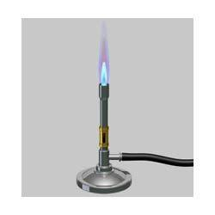

**Figure 1.12** Burner.

**Crucible**

Crucibles are used to contain the sample while it is being heated on a burner.

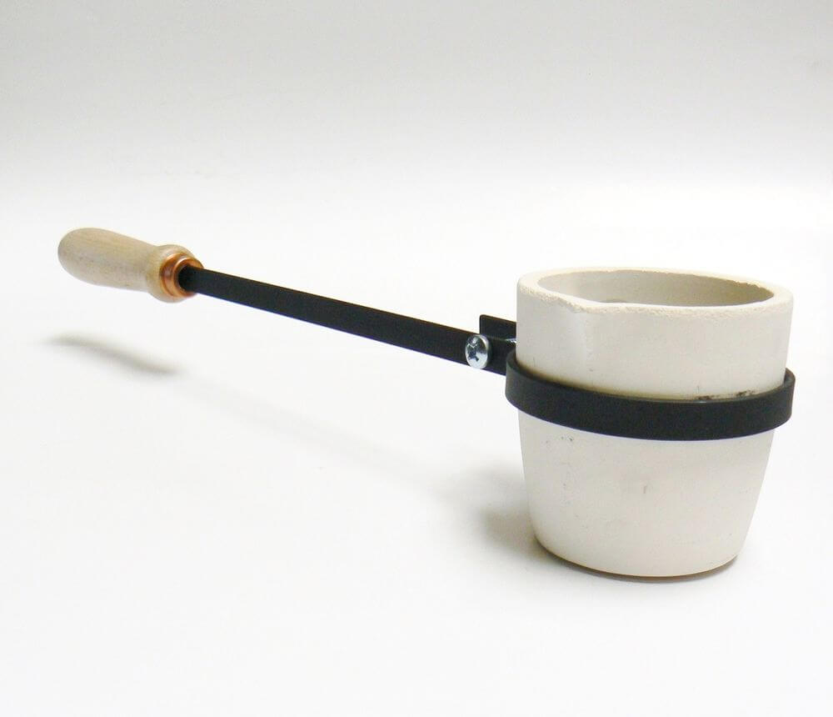

**Figure 1.13** Crucible.

**Hot Plate**

* A hot plate is similar in function to a burner, however it is electric.
* Hot plates deliver a more controlled amount of heat and can be used to warm solutions as opposed to heating them to boiling.
* Many hot plates are also capable of stirring a solution when used with a magnetic mixing bar.

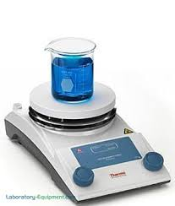

**Figure 1.14** Hot Plate.

**Oven**

Ovens are used to bake chemical reagents or samples to either dry the reagents or to drive off undesirable constituents from a sample.

**Desiccator**

A desiccator is a glass container with an airtight lid.

The desiccator is filled with desiccant and is used to keep chemical reagents and samples dry.

Typically, a sample is heated in an oven to dry it and then placed in the desiccator to cool prior to weighing or undergoing further preparation.

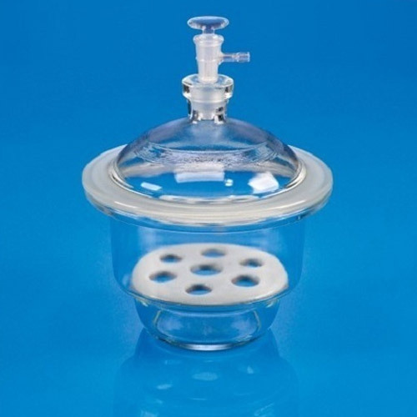

**Figure 1.15** Desiccator.

**Incubator**

* An incubator is a device that will hold a sample at a desired temperature. It is capable of holding the temperature in a very narrow range, usually fluctuating less than 0.5 °C.
* Two common types of incubators are:
* BOD incubators, which are used for holding BOD samples during the 5 day incubation period.
* Bacteriological incubators, which are used to incubate samples undergoing bacteriological analysis.

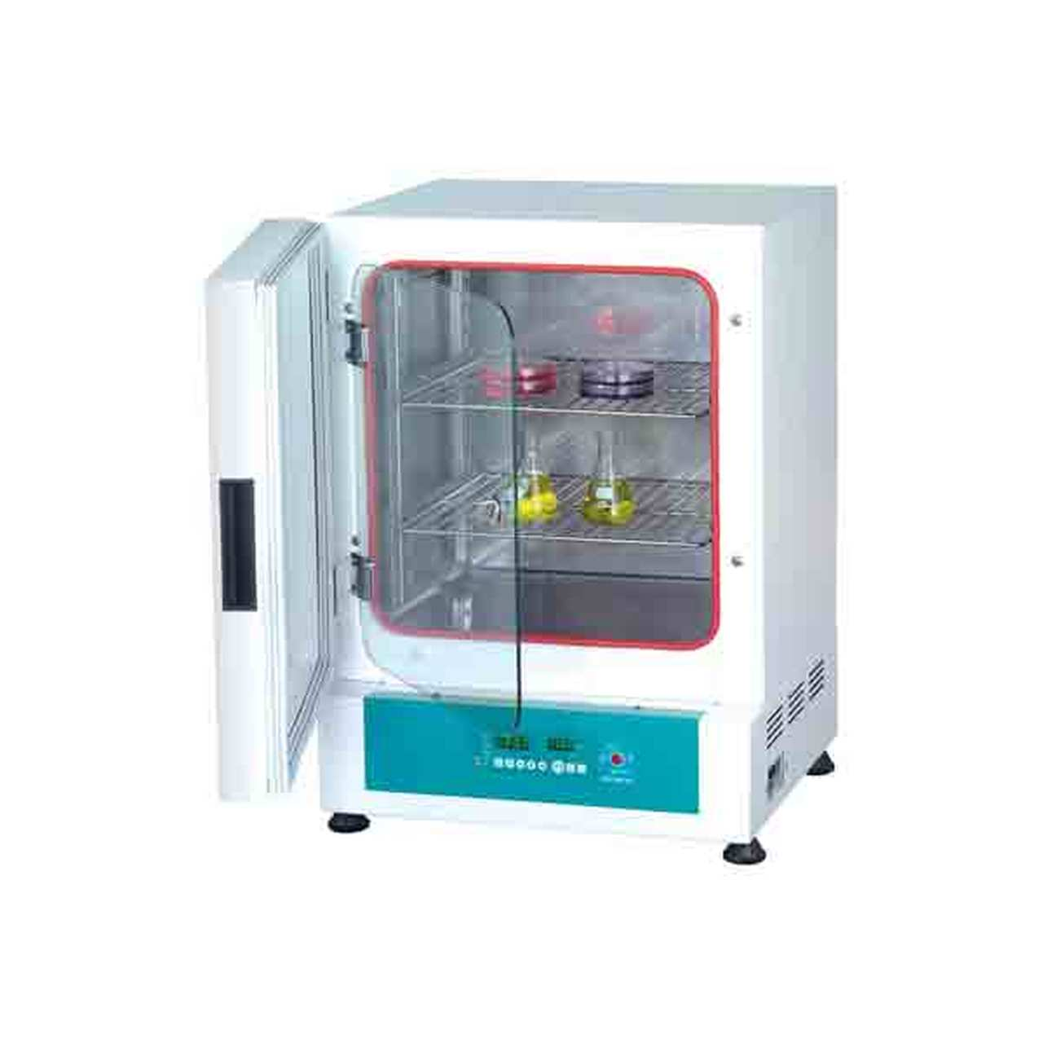

**Figure 1.16** Incubator.

**Fume Hood**

A fume hood is a device that vents potentially dangerous or noxious fumes created by certain chemicals or chemical reactions from the laboratory to the outside atmosphere.

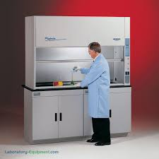

**Figure 1.17** Fume Hood.

**Vacuum Pump**

Vacuum pumps are typically used during the filtration of samples prior to analysis.

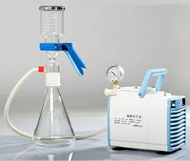

**Figure 1.18** Vacuum pump.