**Lesson 2: Shapes**

**Triangles**

Triangles are polygons with three sides and three interior angles.

**Isosceles triangles** have two sides with the same length. The two angles opposite these two sides have the same measure.

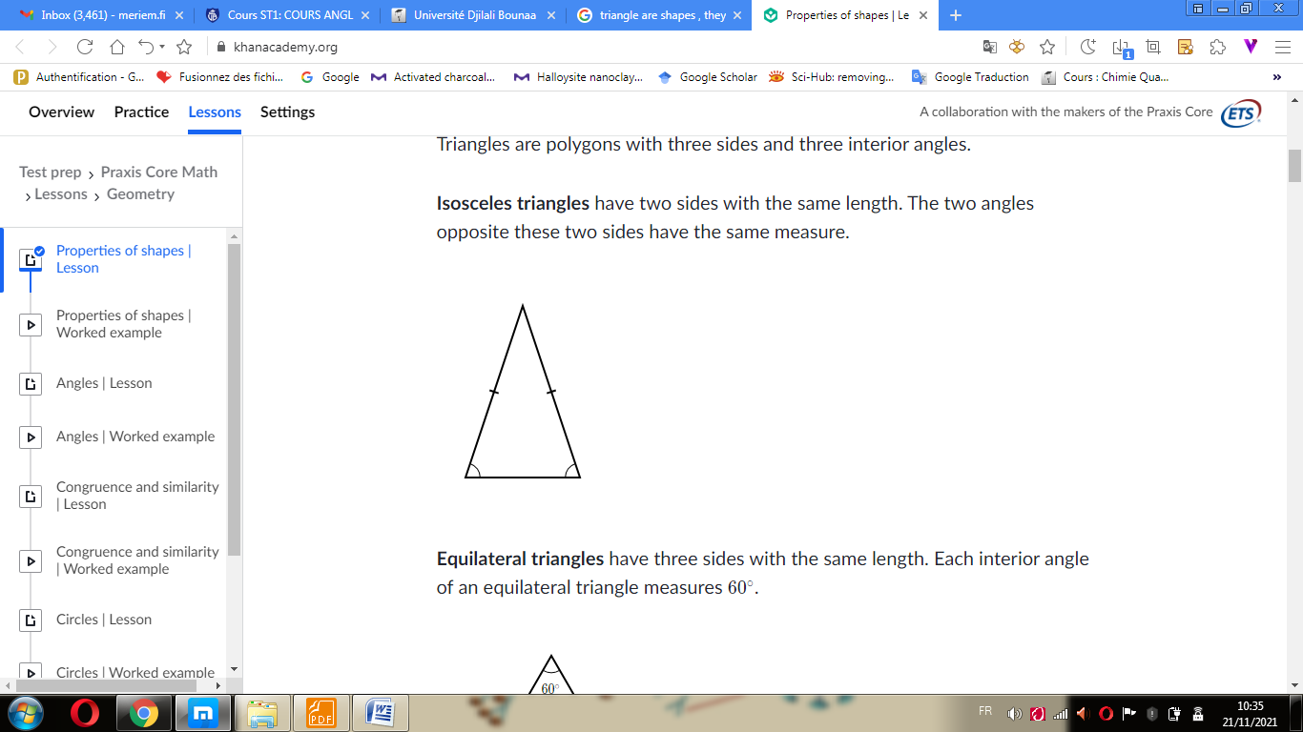

**Equilateral triangles** have three sides with the same length. Each interior angle of an equilateral triangle measures 60°.

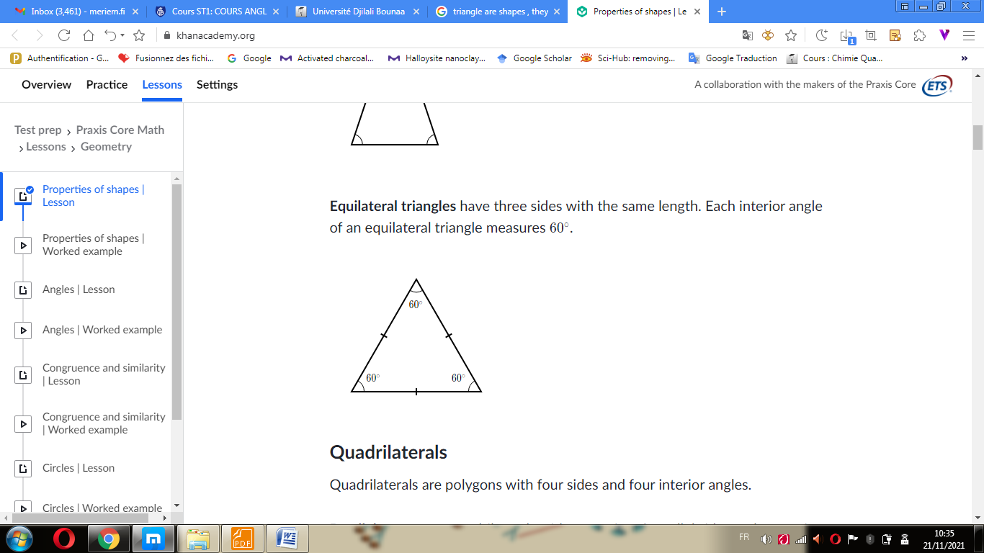

**Quadrilaterals**

Quadrilaterals are polygons with four sides and four interior angles.

**Parallelograms** are quadrilaterals with two pairs of parallel sides and two pairs of angles with the same measure. The opposite sides have the same length, and adjacent angles are supplementary

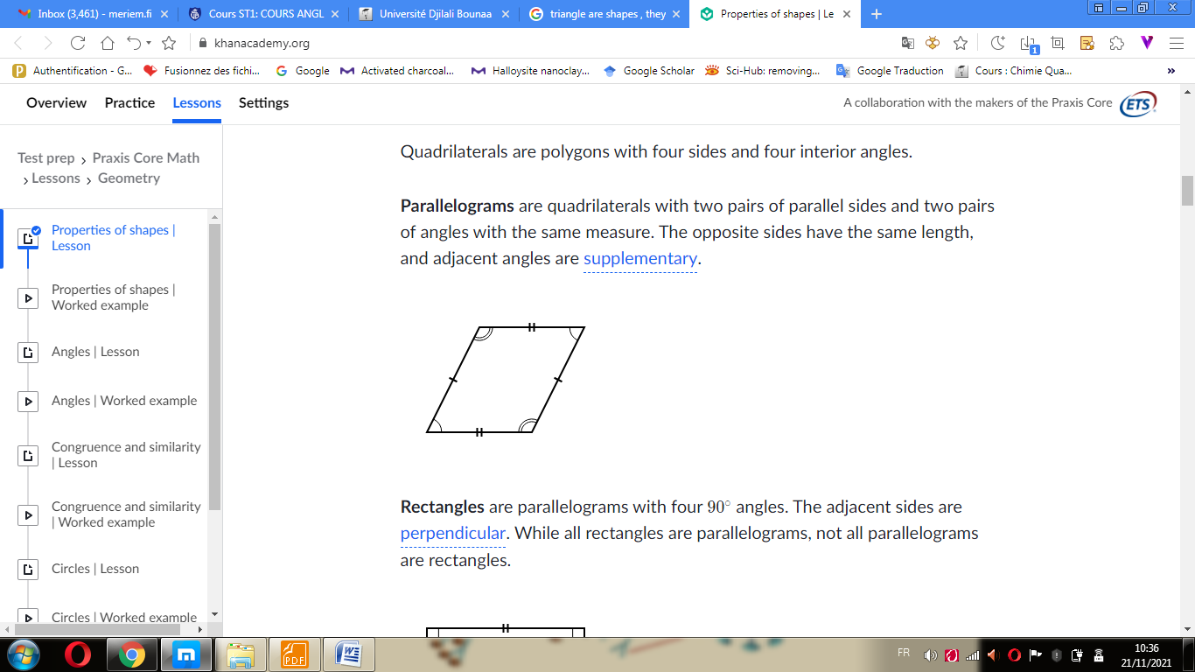

**Rectangles** are parallelograms with four 90° angles. The adjacent sides are perpendicular. While all rectangles are parallelograms, not all parallelograms are rectangles.

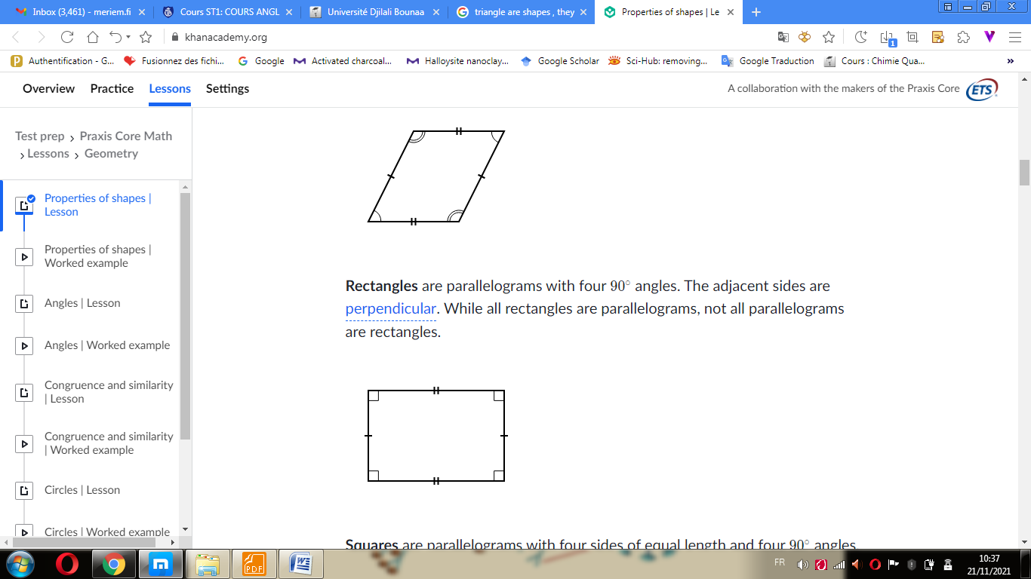

**Squares** are parallelograms with four sides of equal length and four 90^\circ90∘90, degrees angles. While all squares are both rectangles and parallelograms, not all parallelograms are squares and not all rectangles are squares.

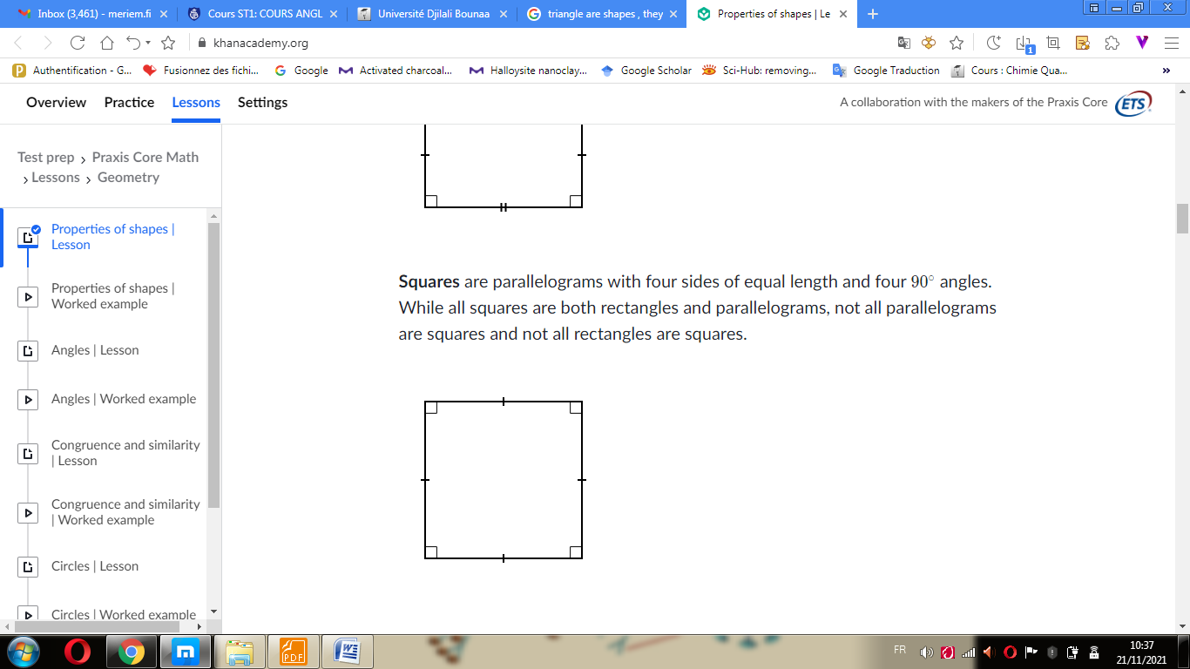

**Exercices** :

1. **If a square is divided into 4 identical areas, which of the following could be the shapes of these areas?**
2. Triangles
3. Rectangles
4. Squares
5. **Which of the following statements must be true for a square?**
6. Opposite sides have equal length.
7. Adjacent angles have the same measure.
8. Adjacent sides are perpendicular.