**Chapter V: Laboratory Equipment (Analytical Equipment)**

**Learning Objectives**

1. List the various types of analytical equipment and explain the use of each.
2. **Introduction**

There are many different types of analytical equipment that could be present in a laboratory. The most common types you may encounter are listed below.

1. **Equipments**

**pH Meter**

* A pH meter is one of the most common pieces of analytical equipment in any laboratory.
* A pH meter measures the pH of samples, which is a measure of the acidity or basicity of a sample.
* Measuring pH is essential since changes in pH can have a significant impact on the effectiveness of many treatment processes.

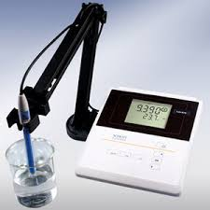

**Figure 2.1** pH Meter.

**Balance**

A balance is used to weigh items that are a part of solids analyses, such as dry chemical, filters or crucibles.

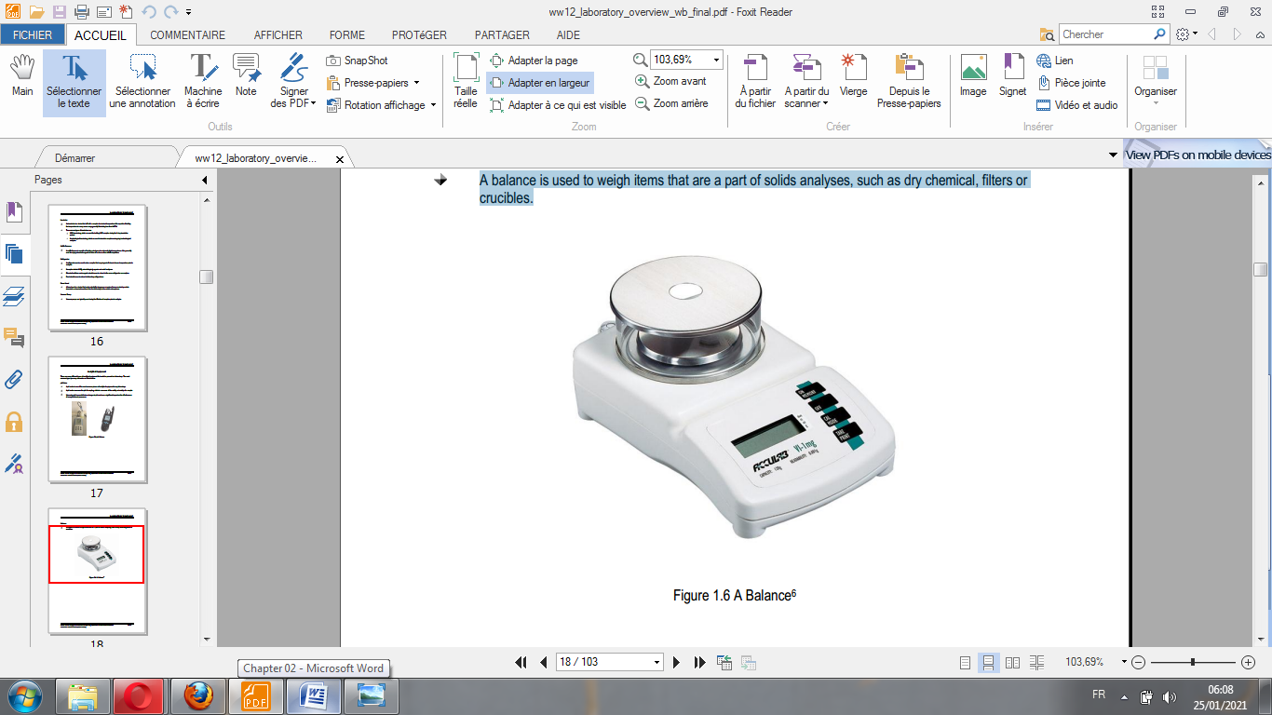

**Figure 2.1** Balance.

**Thermometer**

A thermometer is used to conduct temperature determinations, which can have a significant effect on some treatment processes.

**Spectrophotometer**

Spectrophotometry is a method to measure how much a chemical substance absorbs light by measuring the intensity of light as a beam of light passes through sample solution. The basic principle is that each compound absorbs or transmits light over a certain range of wavelength. This measurement can also be used to measure the amount of a known chemical substance. Spectrophotometry is one of the most useful methods of quantitative analysis in various fields such as chemistry, physics, biochemistry, material and chemical engineering and clinical applications.

A **spectrophotometer** is an instrument that measures the amount of photons (the intensity of light) absorbed after it passes through sample solution. With the spectrophotometer, the amount of a known chemical substance (concentrations) can also be determined by measuring the intensity of light detected. Depending on the range of wavelength of light source, it can be classified into two different types:

* **UV-visible spectrophotometer**: uses light over the ultraviolet range (185 - 400 nm) and visible range (400 - 700 nm) of electromagnetic radiation spectrum.
* **IR spectrophotometer:** uses light over the infrared range (700 - 15000 nm) of electromagnetic radiation spectrum.

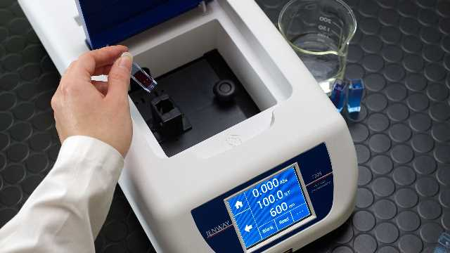 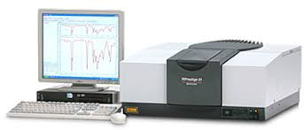

**Figure 2.2** UV-visible spectrophotometer (Left), IR spectrophotometer (right).

**Colorimeter**

* A colorimeter is a type of spectrophotometer that uses chemical reagents to produce a color change in the sample.
* Colorimeters test for a variety of parameters such as chlorine or phosphorus; however, a specific colorimeter will only test for one parameter, not multiple parameters.
* Colorimeters compare the color of the sample (after reagent addition) to a graph of color vs. concentration that is entered into the memory of the instrument.
* A N,N-Diethyl-p-Phenylenediamine kit, commonly called a DPD kit, is a type of colorimeter.

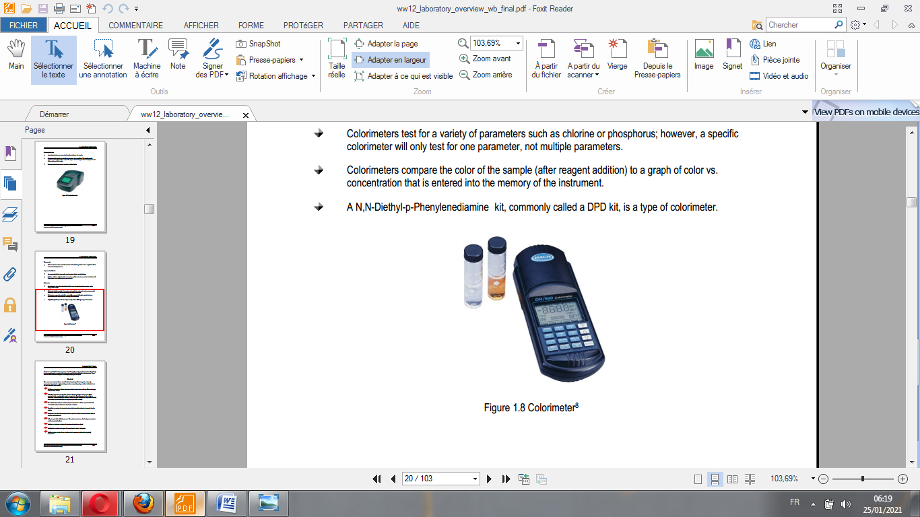

**Figure 2.3** Colorimeter.

**High-performance liquid chromatography (HPLC)**

High-performance liquid chromatography (HPLC), formerly referred to as high-pressure liquid chromatography, is a technique in analytical chemistry used to separate, identify, and quantify each component in a mixture. It relies on pumps to pass a pressurized liquid solvent containing the sample mixture through a column filled with a solid adsorbent material. Each component in the sample interacts slightly differently with the adsorbent material, causing different flow rates for the different components and leading to the separation of the components as they flow out of the column.

HPLC has been used for manufacturing (e.g., during the production process of pharmaceutical and biological products), legal (e.g., detecting performance enhancement drugs in urine), research (e.g., separating the components of a complex biological sample, or of similar synthetic chemicals from each other), and medical (e.g., detecting vitamin D levels in blood serum) purposes.

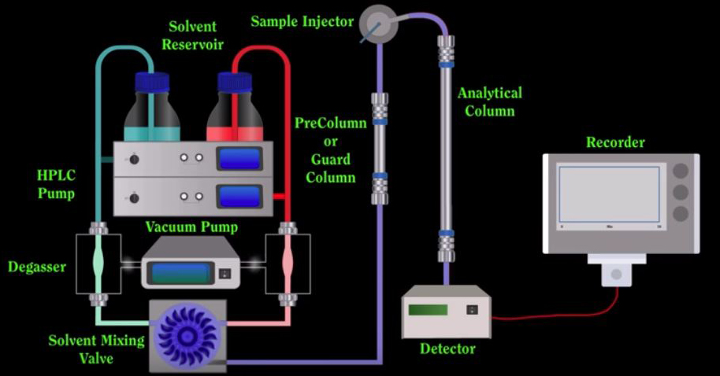

**Figure 2.4** High-performance liquid chromatography.

As shown in Figure 2.4, the schematic of an HPLC instrument typically includes a **degasser,** **sampler, pumps**, and a **detector**. The sampler brings the sample mixture into the **mobile phase** stream which carries it into the **column**. The pumps deliver the desired flow and composition of the mobile phase through the column. The detector generates a signal proportional to the amount of sample component emerging from the column, hence allowing for quantitative analysis of the sample components. A digital microprocessor and user software control the HPLC instrument and provide data analysis. Various detectors are in common use, such as UV/Vis, photodiode array (PDA) or based on mass spectrometry. Most HPLC instruments also have a column oven that allows for adjusting the temperature at which the separation is performed.

**Gas chromatography (GC)**

Gas chromatography (GC) is a common type of chromatography used in analytical chemistry for separating and analyzing compounds that can be vaporized without decomposition. Typical uses of GC include testing the purity of a particular substance, or separating the different components of a mixture (the relative amounts of such components can also be determined). In some situations, GC may help in identifying a compound. In preparative chromatography, GC can be used to prepare pure compounds from a mixture.

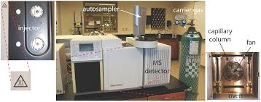

**Figure 2.5** Gas chromatography.

In gas chromatography, the mobile phase (or "moving phase") is a carrier gas, usually an inert gas such as helium or an unreactive gas such as nitrogen. Helium remains the most commonly used carrier gas in about 90% of instruments although hydrogen is preferred for improved separations. The stationary phase is a microscopic layer of liquid or polymer on an inert solid support, inside a piece of glass or metal tubing called a column (an homage to the fractionating column used in distillation). The instrument used to perform gas chromatography is called a 'gas chromatograph' (or "aerograph", "gas separator").

The gaseous compounds being analyzed interact with the walls of the column, which is coated with a stationary phase. This causes each compound to elute at a different time, known as the 'retention time' of the compound. The comparison of retention times is what gives GC its analytical usefulness.

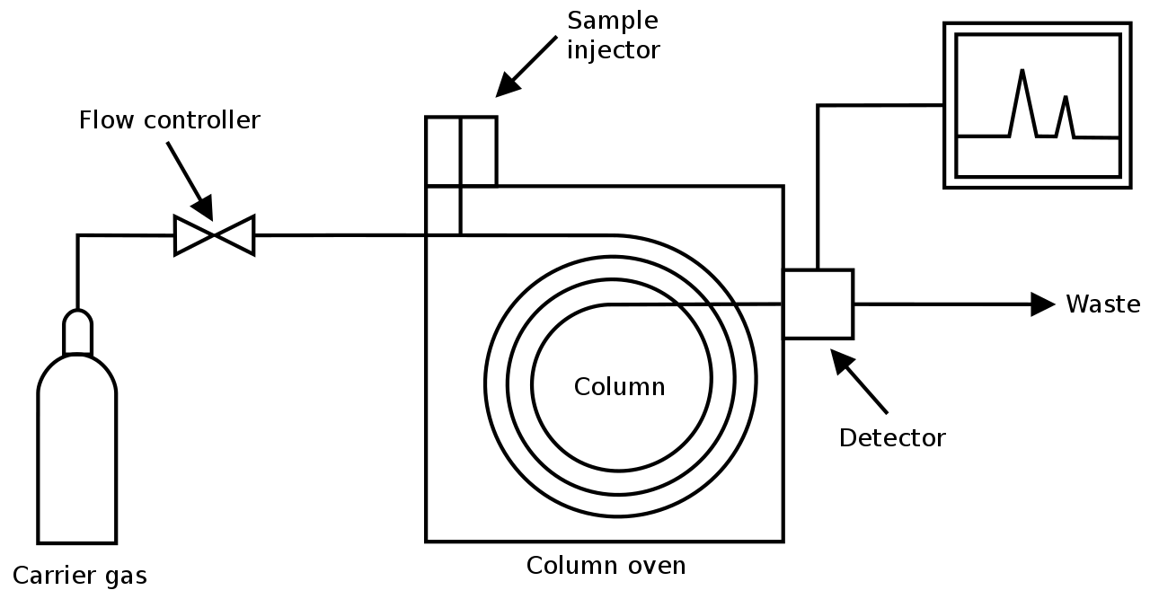

**Figure 2.6** Diagram of a gas chromatograph.