**Lesson 3: Elements and Compounds**

**Learning Objective**

* Differentiate between elements and compounds and explore separation techniques

**Key Points**

* + Elements are the simplest complete chemical substances. Each element corresponds to a single entry on the periodic table. An element is a material that consists of a single type of atom. Each atom type contains the same number of protons.
  + Chemical bonds link elements together to form more complex molecules called compounds. A compound consists of two or more types of elements held together by covalent or ionic bonds.
  + Elements cannot be divided into smaller units without large amounts of energy. Compounds, on the other hand, can have their bonds broken with practical amounts of energy, such as the heat from a fire.
  + Matter can be broken down into two categories: pure substances and mixtures. Pure substances are further broken down into elements and compounds. Mixtures are physically combined structures that can be separated back into their original components.

**Terms**

* Element: Any one of the simplest chemical substances that cannot be changed in a chemical reaction or by any chemical means. Made up of atoms that all have the same number of protons.
* Compound: A substance made from two or more elements. Consists of a fixed ratio of chemically bonded atoms. Has unique properties that are different from the properties of its individual elements.
* Chemical bond : Any of several attractive forces that serve to bind atoms together to form molecules.

**Elements**

A chemical element is a pure substance that consists of one type of atom. Each atom has an atomic number, which represents the number of protons that are in the nucleus of a single atom of that element. The periodic table of elements is ordered by ascending atomic number.

The chemical elements are divided into the metals, the metalloids, and the non-metals.

Metals, typically found on the left side of the periodic table, are:

* often conductive to electricity
* malleable
* shiny
* sometimes magnetic.

Aluminum, iron, copper, gold, mercury and lead are metals.

In contrast, non-metals, found on the right side of the periodic table (to the right of the staircase), are:

* typically not conductive
* not malleable
* dull (not shiny)
* not magnetic.

Examples of elemental non-metals include carbon and oxygen.

Metalloids have some characteristics of metals and some characteristics of non-metals. Silicon and arsenic are metalloids.

As of November, 2011, 118 elements have been identified (the most recently identified was ununseptium, in 2010). Of these 118 known elements, only the first 98 are known to occur naturally on Earth. The elements that do not occur naturally on Earth are the synthetic products of man-made nuclear reactions. 80 of the 98 naturally-occurring elements are stable; the rest are radioactive, which means they decay into lighter elements over timescales ranging from fractions of a second to billions of years.

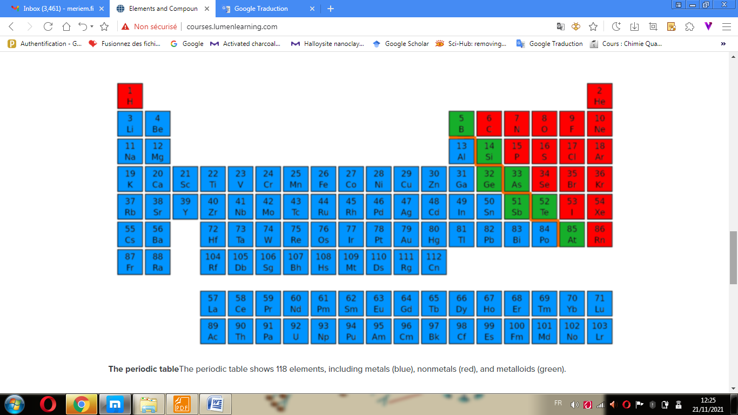

**The periodic table** The periodic table shows 118 elements, including metals (blue), nonmetals (red), and metalloids (green).

*Hydrogen and helium* are by far the most abundant elements in the universe. However, iron is the most abundant element (by mass) in the composition of the Earth, and oxygen is the most common element in the layer that is the Earth’s crust.

**Compounds**

Pure samples of isolated elements are uncommon in nature. While the 98 naturally occurring elements have all been identified in mineral samples from the Earth’s crust, only a small minority of them can be found as recognizable, relatively pure minerals. Among the more common of such “native elements” are copper, silver, gold, and sulfur. Carbon is also commonly found in the form of coal, graphite, and diamonds. The noble gases (e.g., neon) and noble metals (e.g., mercury) can also be found in their pure, non-bonded forms in nature. Still, most of these elements are found in mixtures.

When two distinct elements are chemically combined—i.e., chemical bonds form between their atoms—the result is called a chemical compound. Most elements on Earth bond with other elements to form chemical compounds, such as sodium (Na) and Chloride (Cl), which combine to form table salt (NaCl). Water is another example of a chemical compound. The two or more component elements of a compound can be separated through chemical reactions.

Chemical compounds have a unique and defined structure, which consists of a fixed ratio of atoms held together in a defined spatial arrangement by chemical bonds. Chemical compounds can be:

molecular compounds held together by covalent bonds

salts held together by ionic bonds

intermetallic compounds held together by metallic bonds

complexes held together by coordinate covalent bonds.

Pure chemical elements are not considered chemical compounds, even if they consist of diatomic or polyatomic molecules (molecules that contain only multiple atoms of a single element, such as H2 or S8).