**Lesson 5: The lathe machine**

**The lathe machine:**

In the mechanical engineering field lathe plays an important role in manufacturing. Lathe machine refers to a machine tool which is used to remove unwanted metals from the work piece to give a desired shape and size. It operates on the principle of a rotating workpiece and a fixed cutting tool. It was invented by David Wilkinson.

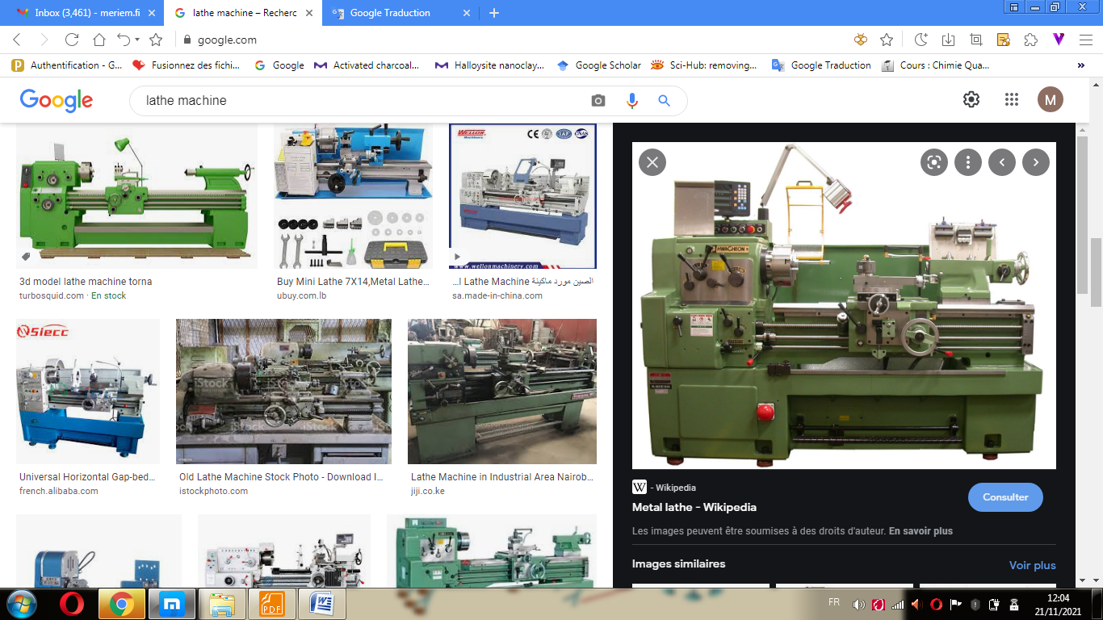

Lathe machine

**What is welding?**

• Welding is the most economical and efficient way to join metal’s permanently. It is the only way of joining two or more pieces of metal to make them act as a single one.

• Welding is the process by which two pieces of metal can be joined together through the use of extreme heat and sometimes the addition of some other metals causes the metalic structures of the two pieces to join together and become one.

**A welder should wear:**

• *Fire resistant clothing* that protects against: heat, fire, burns.

•*Welding helmet*: protects eyes and face from flying particles, intense light, irritation and chemical burns.

• *Respirators*: protects against fumes and oxides.

• *Earmuffs*: protects against noise.

• *Boots and gloves*: protects feet and hands from heat, burns, electric shock.

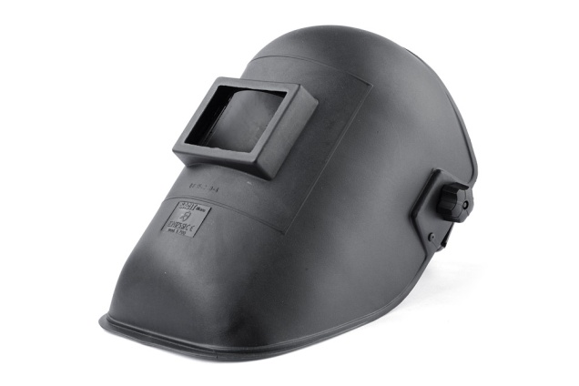

Welding helmet

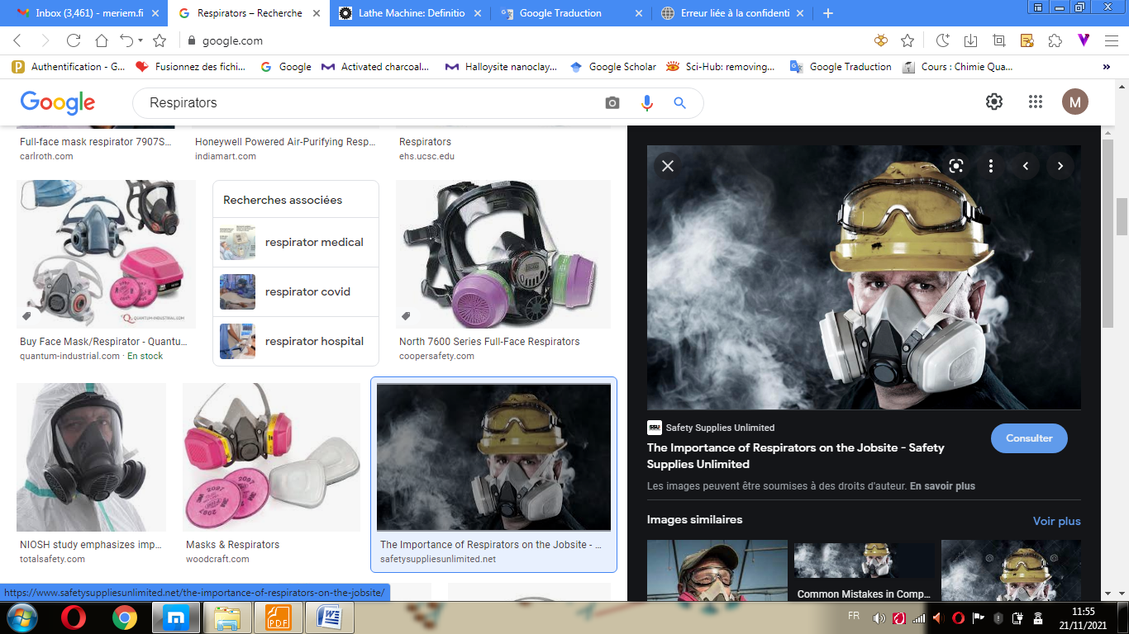

Respirators

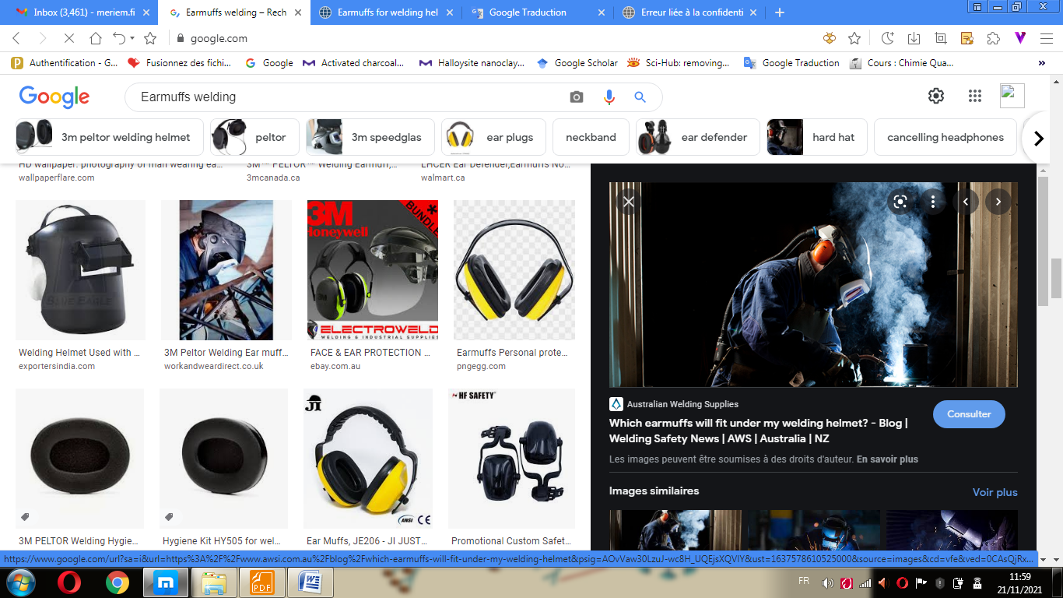

Earmuffs

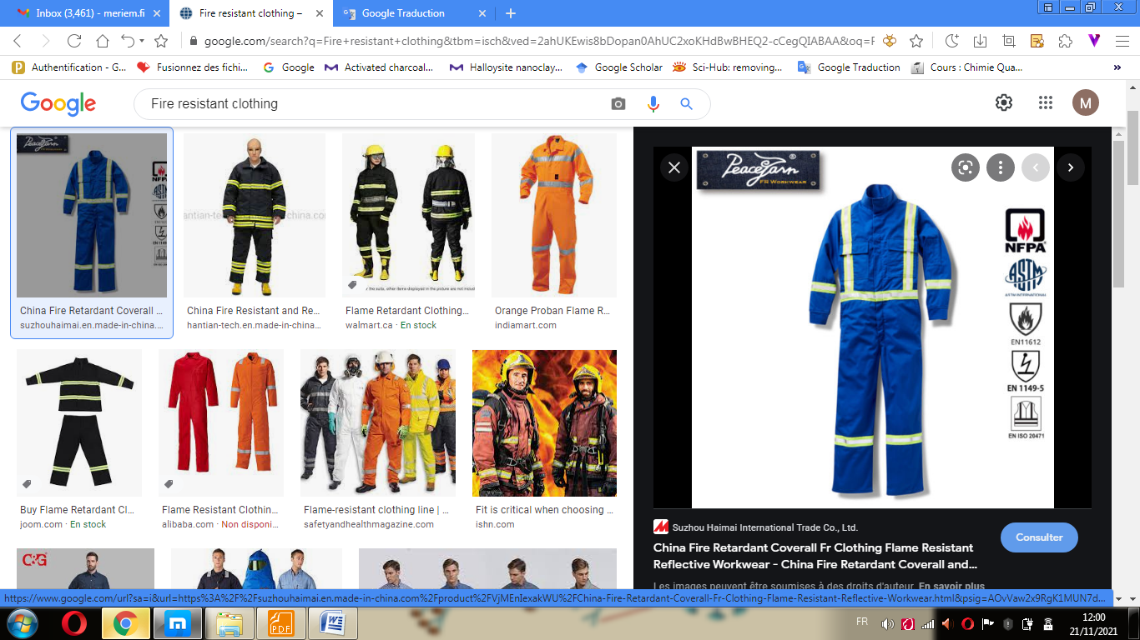

Fire resistant clothing

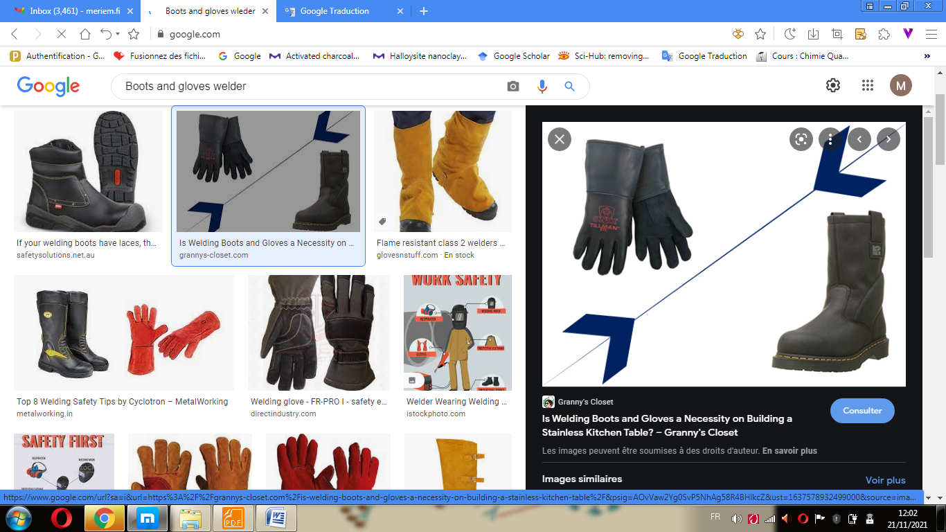

Boots and gloves