**Chapter II : COAL AND PETROLEUM**

***Course 01 : Coal***

We use various materials for our basic needs. Some of them are found in nature and some have been made by human efforts. In the light of the availability of various resources in nature, natural resources can be broadly classified into two kinds:

(i) ***Inexhaustible Natural Resources***: These resources are present in unlimited quantity in nature and are not likely to be exhausted by human activities.

Examples are: sunlight, air .

(ii) ***Exhaustible Natural Resources***: The amount of these resources in nature is limited. They can be exhausted by human activities. Examples of these resources are forests, wildlife, minerals,coal, petroleum, natural gas etc.

In this chapter we will learn about some exhaustible natural resources like coal, petroleum and natural gas. These were formed from the dead remains of living organisms (fossils). So, these are all known as **fossil fuels**.

**5.1 Coal**

You may have seen coal or heard about it (**Fig.1**). It is as hard as stone and is black in colour . Coal is one of the fuels used to cook food. Earlier, it was used in railway engines to produce steam to run the engine. It is also used in thermal power plants to produce electricity. Coal is also used as a fuel in various industries

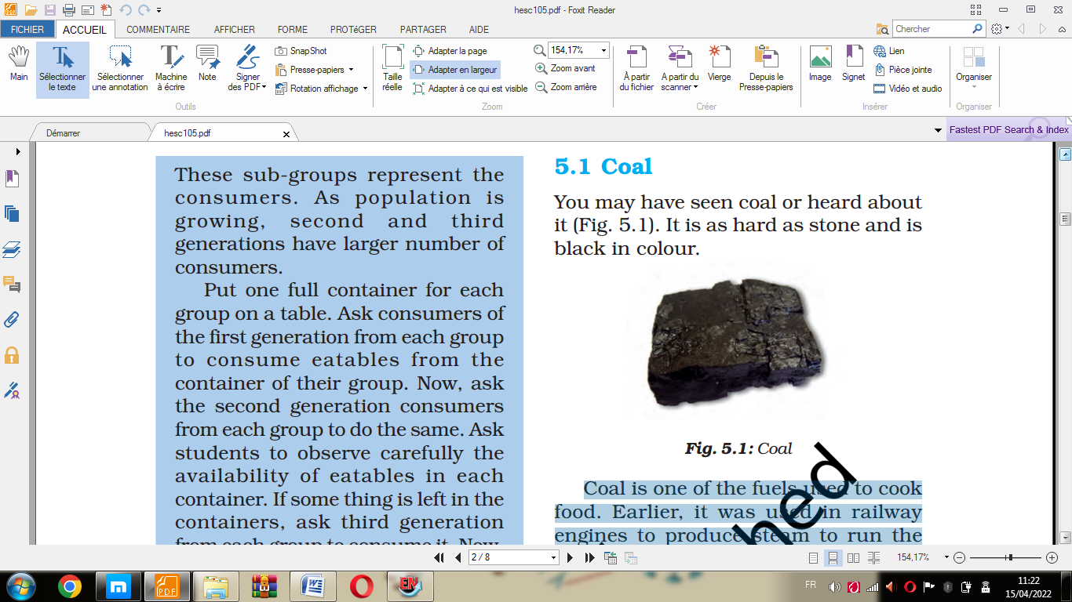

**Fig.1** **Coal**

**Story of Coal**

Where do we get coal from and how is it formed?

About 300 million years ago the earth had dense forests in low lying wetland areas. Due to natural processes, like flooding, these forests got buried under the soil. As more soil deposited over them, they were compressed. The temperature also rose as they sank deeper and deeper. Under high pressure and high temperature, dead plants got slowly converted to coal. As coal contains mainly carbon, the slow process of conversion of dead vegetation into coal is called carbonisation. Since it was formed from the remains of vegetation, coal is also called a fossil fuel. A coal mine is shown in **Fig.2**.

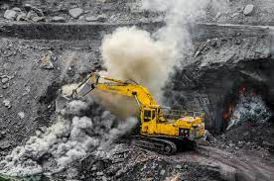

**Fig.2**. Coal mine.

When heated in air, coal burns and produces mainly carbon dioxide gas. Coal is processed in industry to get some useful products such as coke, coal tar and coal gas.

**Coke**

It is a tough, porous and black substance. It is an almost pure form of carbon. Coke is used in the manufacture of steel and in the extraction of many metals.

**Coal Tar**

It is a black, thick liquid (**Fig.3**) with an unpleasant smell. It is a mixture of about 200 substances. Products obtained from coal tar are used as starting materials for manufacturing various substances used in everyday life and in industry, like synthetic dyes, drugs, explosives, per fumes, plastics, paints, photographic materials, roofing materials, etc. Interestingly, naphthalene balls used to repel moths and other insects are also obtained from coal tar .



**Fig.3** Coal tar.

These days, bitumen, a petroleum product, is used in place of coal-tar for metalling the roads.

**Coal gas**

Coal gas is obtained during the processing of coal to get coke. It is used as a fuel in many industries situated near the coal processing plants.