Chapter III. Physics Laboratory Equipment
Introduction
Physics is the natural science that studies matter, its motion and behavior through space and time and that studies the related entities of energy and force. Physics is one of the most fundamental scientific disciplines, and its main goal is to understand how the universe behaves. Its scope further trickles down to not only the behavior of objects under the action of given forces but also the nature and origin of gravitational, electromagnetic, and nuclear force fields.
Theory and experiment go hand in hand. An experiment that results in measurement of a phenomena can predict or confirm a theory. While a theory that predicts the outcome of an experiment is considered valid. And these list of equipment do just that by providing the measurement of phenomena in a controlled environment.
ELECTRICAL EQUIPMENT
RESISTOR
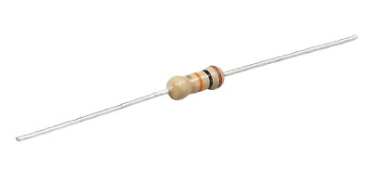
A resistor is an electrical component that provides electrical resistance in a circuit. It is used to reduce current flow, adjust signal levels, to divide voltages, bias active elements etc.
Multimeter
A multimeter is an electronic measuring instrument that combines several measurement functions in one unit. It can measure voltage, current, and resistance. Analog multimeter uses moving pointer to display readings while digital version displays it on a screen.
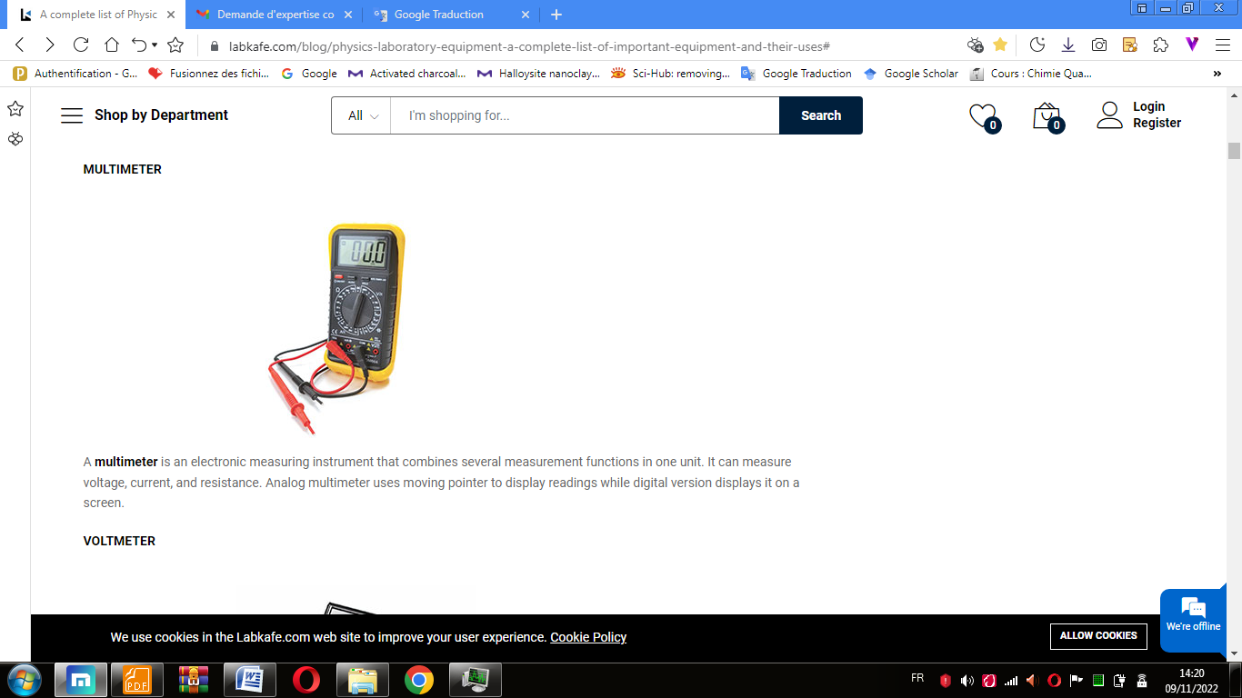

Voltmeter
A voltmeter is an instrument used for measuring electrical potential difference between two points in an electric circuit. Analog voltmeters move a pointer across a scale in proportion to the voltage of the circuit while digital voltmeters give a numerical display of voltage by use of an analog to digital converter.
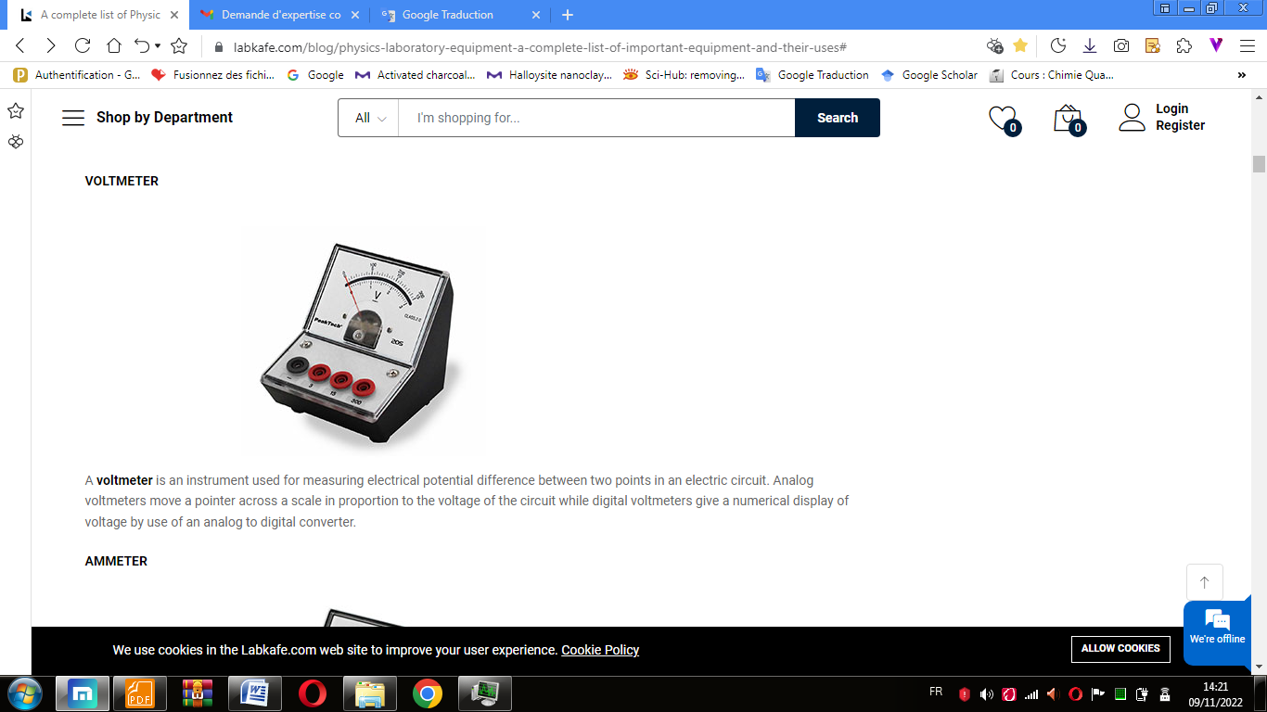
Ammeter
An ammeter is an instrument used to measure the current, either direct or alternating electric current, in a circuit. Electric currents are measured in amperes (A), hence the name. Analog ammeters move a pointer across a scale in proportion to the current of the circuit while digital ammeters give a numerical display of current by use of an analog to digital converter.
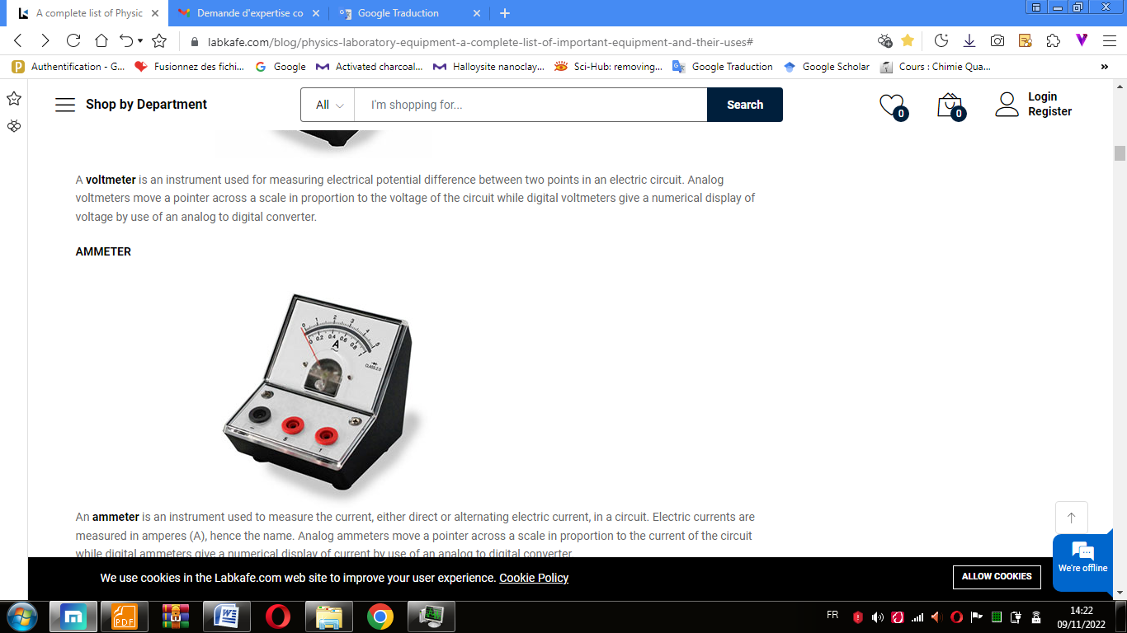
Galvanometer
The galvanometer is the device used for detecting the presence of small current and voltage or for measuring their magnitude. The galvanometer is mainly used in the bridges and potentiometer where they indicate the null deflection or zero current. It works as an actuator, by producing a rotary deflection (of a "pointer"), in response to electric current flowing through a coil in a constant magnetic field.
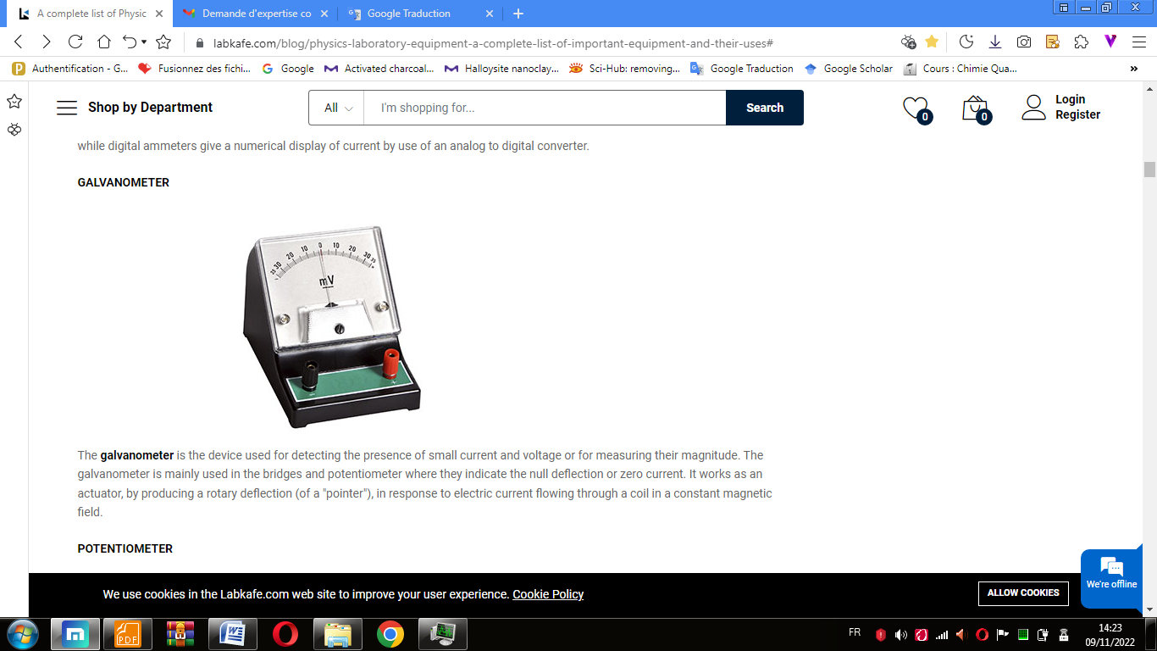
Potentiometer
A potentiometer is a three-terminal resistor with a sliding or rotating contact that forms an adjustable voltage divider. If only two terminals are used, one end and the wiper, it acts as a variable resistor or rheostat.
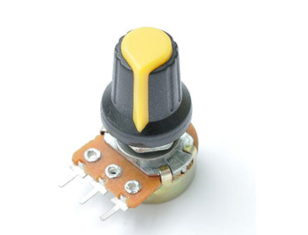
Battery eliminator
A battery eliminator is a device powered by an electrical source other than a battery, which then converts the source to a suitable DC voltage that may be used by a second device designed to be powered by batteries.
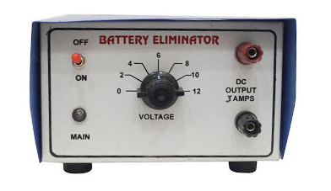
DANIEL CELL
The Daniel cell is a type of electrochemical cell. It consists of a copper pot filled with cuprous sulfate solution, in which was immersed an unglazed earthenware container filled with sulfuric acid and a zinc electrode. Zinc sulfate may be substituted for the sulfuric acid.
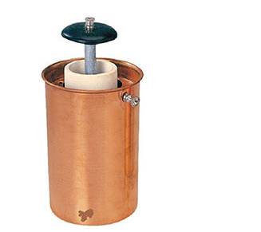
Ohm’s Law apparatus
Ohm’s Law apparatus is used to verify Ohm’s law i.e. potential difference (voltage) across an ideal conductor is proportional to the current through it. The constant of proportionality is called the "resistance", R. and is termed as V=IR. The apparatus consists of one wire wound rheostat, one moving coil voltmeter and one moving coil ammeter, mounted on a bakelite plate in a wooden case. With four terminals, two for battery connection and two for resistance coil.
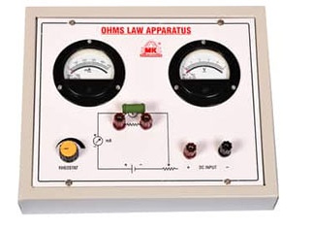
MAGNETIC EQUIPMENT
COMPASS
A compass is an instrument that shows directions. It has a needle, called a compass rose, which points in North-South direction. The "N" mark on the rose points northward. Compasses often display markings for angles in degrees in addition to the rose. North corresponds to 0°, and the angles increase clockwise i.e. east is 90°, south is 180°, and west is 270°.
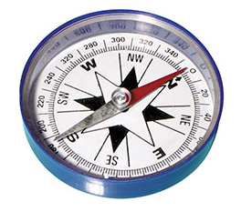

Magnet
A magnet is a material or object that produces a magnetic field that exerts a force, called magnetic force, which pulls on other ferromagnetic materials, such as iron, and attracts or repels other magnets. It has two poles called North and South pole.
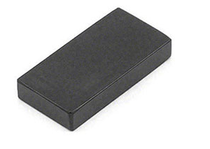
OPTICAL EQUIPMENT
PRISM
A prism is a transparent optical element with flat, polished surfaces that refract light. At least two of the flat surfaces must have an angle between them. The traditional geometrical shape is that of a triangular prism with a triangular base and rectangular sides. Prisms can be made from any material that is transparent to the wavelengths for which they are designed. Typical materials include glass, plastic, and fluorite. It can be used to split light into its constituent spectral colors (the colors of the rainbow) where each color has different wavelengths.
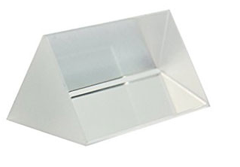
Lens
A lens is an optical device that focuses or disperses a light beam by means of refraction. A lens can focus light to form an image, unlike a prism, which refracts light without focusing. Lenses are made from materials such as glass or plastic, and are ground and polished or moulded to a desired shape.
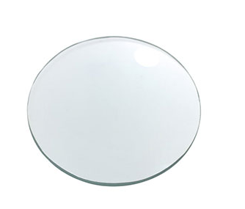
Optical bench
The optical bench is a long steel pipe with a linear scale applied to it. It consists of holders for light sources, lenses and screens are placed on the apparatus so that image formation can be observed. An object is put on one side and corresponding image distance can be measured.
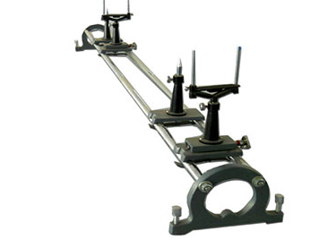

WAVES AND SOUND RELATED EQUIPMENT
TUNING FORK
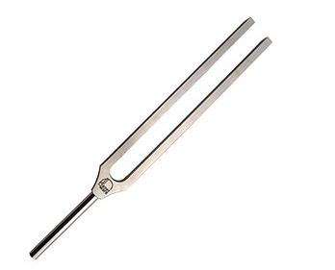
A tuning fork is a two-pronged fork with the prongs (tines) formed from a U-shaped bar of elastic metal. On striking these tines against a surface, it resonates at a specific constant pitch. The pitch that a particular tuning fork generates depends on the length and mass of the two prongs. The back and forth vibration of the tines produce disturbances of surrounding air molecules. As a tine stretches outward from its usual position, it compresses surrounding air molecules into a small region of space; this creates a high pressure region next to the tine. As the tine then moves inward from its usual position, air surrounding the tine expands; this produces a low pressure region next to the tine. The high pressure regions are known as compressions and the low pressure regions are known as rarefactions. As the tines continue to vibrate, an alternating pattern of high and low pressure regions are created. These regions are transported through the surrounding air, carrying the sound signal from one location to another.
VIBRATION GENERATOR
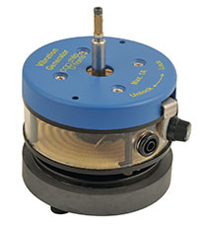

The Vibration Generator, as the name suggests, gives mechanical oscillations when fed by signals from an oscillator/A.F. amplifier. The frequency response encompasses the whole of the audio spectrum and beyond. Electrical input is made via two 4 mm sockets and the mechanical output is provided by a shaft terminating in a pair of clamping nuts.
RESONANCE APPARATUS
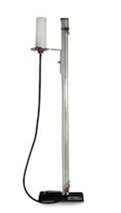
A resonance apparatus is used in locating resonance positions in air columns. These resonance positions help in calculating the speed of sound using the water level and the frequency of the tuning fork used.

SONOMETER
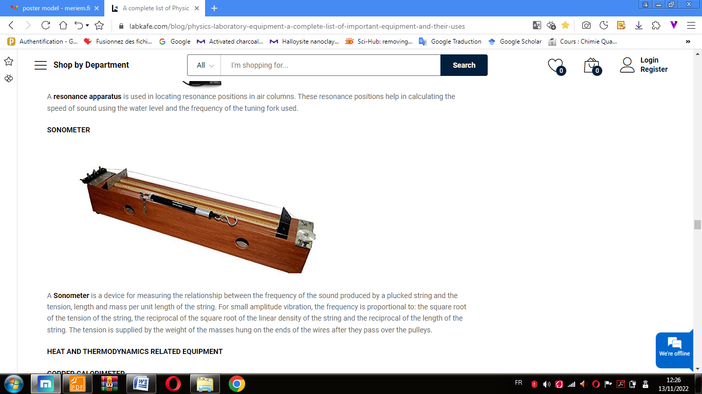
A Sonometer is a device for measuring the relationship between the frequency of the sound produced by a plucked string and the tension, length and mass per unit length of the string. For small amplitude vibration, the frequency is proportional to: the square root of the tension of the string, the reciprocal of the square root of the linear density of the string and the reciprocal of the length of the string. The tension is supplied by the weight of the masses hung on the ends of the wires after they pass over the pulleys.
HEAT AND THERMODYNAMICS RELATED EQUIPMENT
THERMOMETER
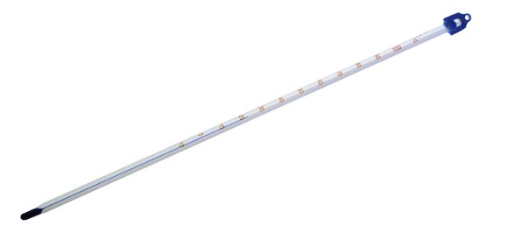
A thermometer is a device that measures temperature or change in temperature for a given body. It consists of a temperature sensor i.e. the bulb of a mercury-in-glass thermometer which expands with a change in temperature, and visible scale that converts this change into a numerical value.

MEASURING EQUIPMENT

METER SCALE
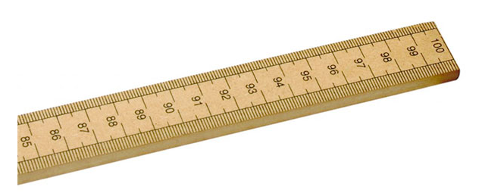
Meter Scale is the most common measuring tool that we use in day-to-day activity. Often known as a ruler, it has equally spaced markings along its length used to measure distances along the straight lines.

VERNIER CALLIPER
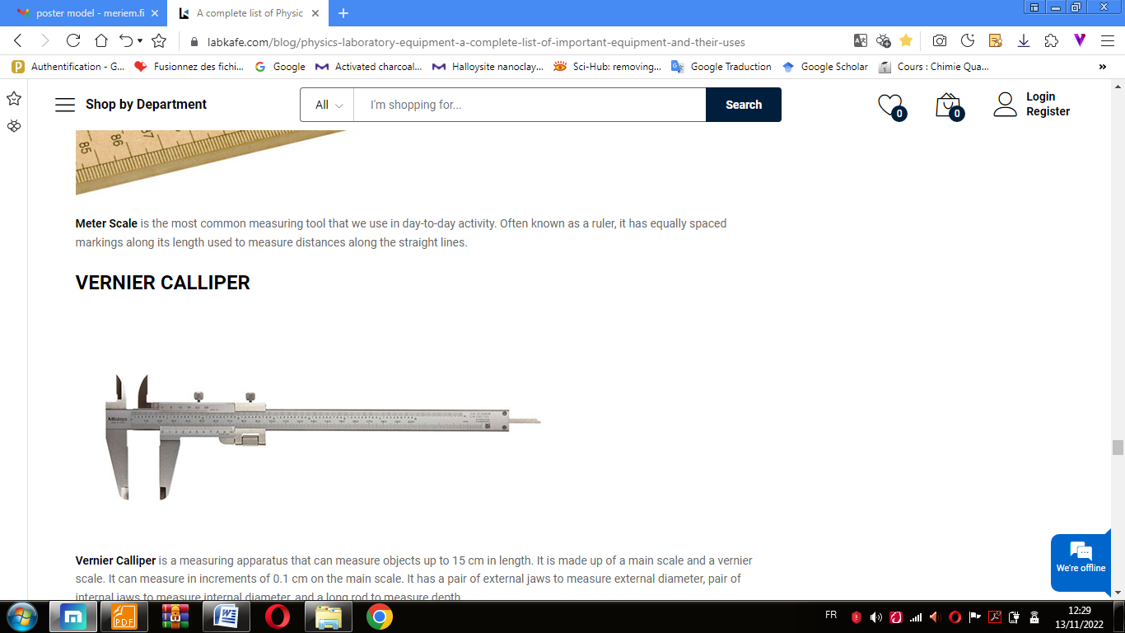
Vernier Calliper is a measuring apparatus that can measure objects up to 15 cm in length. It is made up of a main scale and a vernier scale. It can measure in increments of 0.1 cm on the main scale. It has a pair of external jaws to measure external diameter, pair of internal jaws to measure internal diameter, and a long rod to measure depth.

SCREW GAUGE
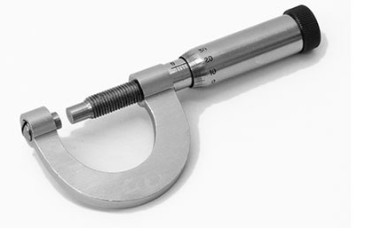
A screw gauge is a measuring apparatus that can measure dimensions in the range of millimeters up to 5 cm. With a least count of 0.01mm, it can measure the dimension in increments of 0.01mm. Screw Gauges are widely used to measure the diameter of wires, screws, and bolts.

STOP CLOCK
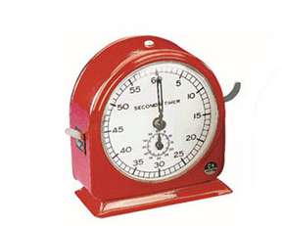
A Stop Clock is a clock designed to measure the amount of time elapsed from a particular time when it is activated to the time when the piece is deactivated. It is used to measure time in experiments (like in pendulum-based experiments) where a brief period of time measurement is needed to do calculations.

TRIPLE BEAM BALANCE
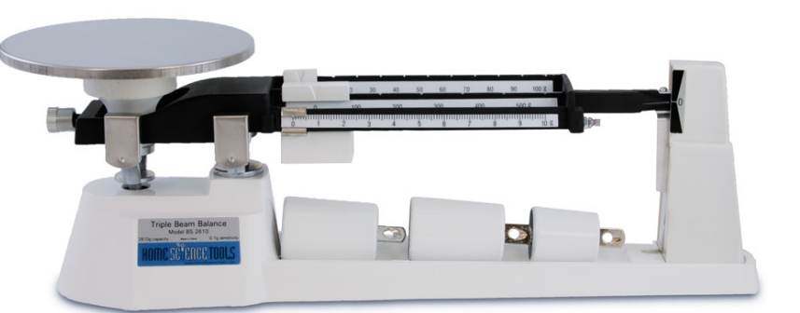
The triple beam balance is a measuring instrument that measures mass very precisely. It has a reading error of +/- 0.05 gram. The name refers to the three beams including the middle beam which is the largest size, the front beam which is the medium size, and the far beam which is the smallest size. The middle beam reads in 100-gram increments, the front beam can read from 0 to 10 grams, and the far beam reads in 10-gram increments. It can measure an object's mass directly or find mass by difference for liquid.

