CURRICULUM VITAE
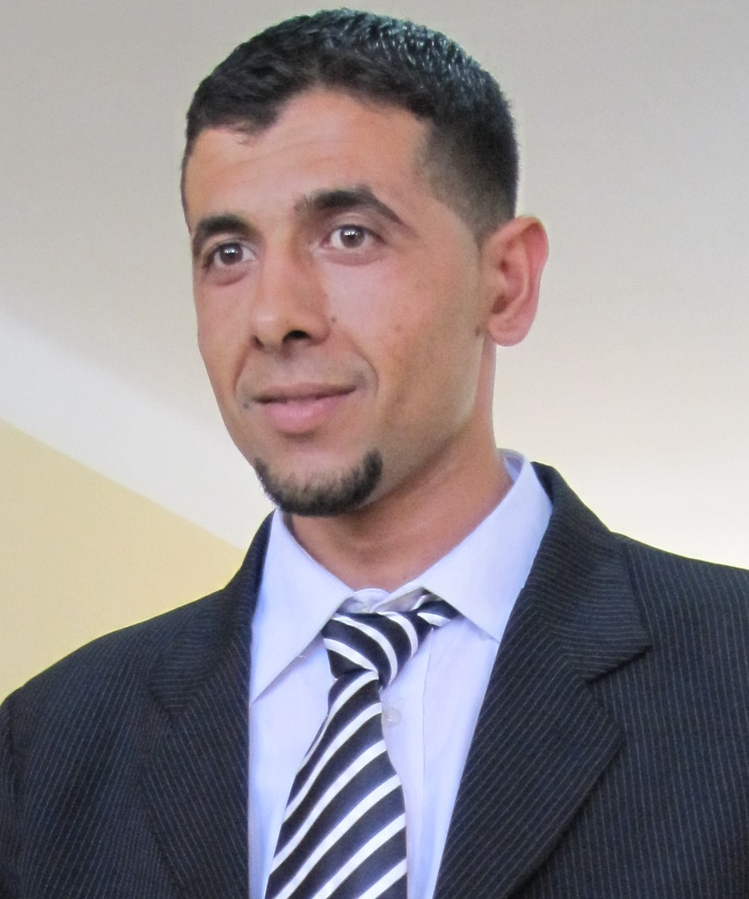 |  |  | Dr. GADOURI Hamid was born in 1986 in Tacheta Zougagha, Ain Defla, Algeria. He received his both Licence & Master degree’s in Geotechnical Engineering from Djillali Bounaama University in 2008 and 2010, respectively. Then, he received the Ph.D degree in Construction Engineering and Geotechnical Risks branch from Yahia Farès University of Medea in 2017 under both supervisors of Pr. HARICHANE Khelifa and Pr. GHRICI Mohamed. His research interests are ground improvement methods, chemical soil stabilization, sulfates effects on stabilized soil, soil slope stability, soil and rock mechanics, resistance of materials, pavement engineering, environmental geotechnics, artificial neural networks (ANNs), soil dynamics and development, statistical models for more than 13 years. He is the author and co-author of more than ten scientific papers and he is the reviewer of both American Journal of Civil Engineering (AJCE) & Cogent Engineering. He has considerable experiences as a teacher at Yahia Farès University and a better practical working at Habitat Laboratory and Construction Center (HLCC), Oued Smar, Algiers, Algeria. At present, he is a researcher member in Geomaterials Laboratory at Hassiba Benbouali University, Chlef 02000, Algeria & a Teacher at Djilali Bounaama University Khemis‒Miliana as doctor of Geotechnical Engineering.
Contact Information
Dr. Hamid GADOURI
Tel/Fax: +213 (0) 27.72.17.94
Mobile: +213 (0) 790.982.163
+213 (0) 663.989.621
E-mail: h.gadouri@univ-chlef.dz
hamid_gadouri2000@yahoo.fr
hamid_gadouri2015@yahoo.fr
ORCID: http://orcid.org/0000-0002-0753-3569
Web-site: http://www.hamidgadouri.jimdo.com
Google-Scholar: https://scholar.google.com/citations?user=y9aKOrAAAAAJ&hl=fr
Linked-In: https://dz.linkedin.com/in/hamid-gadouri-69b990b9
Res-Gate: https://www.researchgate.net/researcher/2116380290_Hamid_Gadouri
Specialization
Construction Engineering and Geotechnical Risks (Ingénierie de Construction et Risques Géotechniques)
Educational Qualifications
Ph.D  (2017) |  | In Construction Engineering and Geotechnical Risks (Chemical Soil Stabilization) at University of Yahia Farès, Medea, Algeria.  Thesis title: Influence of the presence of sulphates on the treatment of clayey soils with mineral additions (In French: Influence de la présence des sulfates sur le traitement des sols argileux par des ajouts minéraux).
Master (2010) |  | In Geotechnical Engineering from the University of Djilali Bounaama, Khemis‒Miliana, Ain Defla, Algeria.  Thesis: Analysis and interpretation of geotechnical parameters of Plaisancian marls of El‒Achour and Dely Brahim regions, Algiers Department (In French: Analyse et interprétation des paramètres géotechniques des marnes du Plaisancien de la région d'El–Achour et Dely Brahim, Wilaya d’Alger).
Licence (2008) |  | In Geotechnical Engineering from the University of Djilali Bounaama, Khemis‒Miliana, Ain Defla, Algeria.  Thesis: Contribution to a geotechnical, geological and hydro-geological study of a civil engineering project (Bridge) on the Cheliff river, Ain Defla Department (In French: Contribution à une étude géotechnique, géologique et hydrologique d'un ouvrage d'art (Pont) sur l'oued Cheliff, Wilaya d’Ain Defla).
Teaching
Sep 2014 – At present |  |  |  | A Researcher member in Geomaterials Laboratory at Hassiba Benbouali University, Chlef 02000, Algeria & a Teacher at Djilali Bounaama University Khemis‒Miliana as doctor of Geotechnical Engineering.
Sep. 2013 – Jan. 2014 |  |  |  | Practical Works on Soil and Soil-Interaction Modeling of different Civil Engineering Projects using PLAXIS Program 8.2 (For Ms.1), Civil Engineering, Medea University
Sep. 2012 – Jan. 2013 |  |  |  | Practical Works in Geotechnical Tests (For Lice. 3), Civil Engineering, Medea University
Sep. 2011 – Jan. 2012 |  |  |  | Practical Works in Materials resistance (For Lice.2), Civil Engineering, Medea University
Areas of Research Interests
- Ground Improvement Methods (Méthodes d'Amélioration des Sols)
- Chemical Soil Stabilization (Stabilisation Chimique des Sols)
- Effects of Sulphates on Chemical Soil Stabilization (Effets des Sulfates sur la Stabilisation Chimique des Sols)
- Good Practices on Laboratory Soil Tests (Bonne Pratique en Essais de Laboratoires sur les Sols)
- Resistance of Materials (Résistances des Matériaux)
- Soil Stabilization for Pavement Engineering (Stabilisation des Sols pour les Chaussées Routières)
- Analysis and synthesis of geotechnical data and Writing of Soils technical reports (Analyse et Synthèse des Données Géotechniques et Rédaction des rapports techniques de Sols)
- Determination of In-Situ Tests Position Points (Détermination de la Positions des Points des Essais In-Situ)
Major Research Contributions and Their Main Subject Areas
2014‒2015 | Master Thesis: influence of sulphates on the stabilization of clayey soils by using mineral additives.  In french: Influence des sulfates sur la stabilisation des sols argileux par des ajouts minéraux.  Subject Areas: Geotechnical Engineering, Chemical Soil Stabilization.  University: Khemis-Miliana University.  Department: Earth Sciences.  Authors: Marwana Aminou, Muangongo Ivanete, Belhadj Fatima Zouhera and Gadouri Hamid.  --------------------------------------------------------------------------  Master Thesis: Geotechnical parameters Analysis and soil-structure interaction modeling in static and dynamic load in order to choose the type of foundation: Case of El-Achour and Daly-Brahim regions.  In french: Analyse des paramètres géotechniques et modélisation de l’interaction sol-structure en charge statique et dynamique pour le choix du type de fondation: Cas de la région d’El-Achour et Daly-Brahim.  Subject Areas: Soil Dynamics, Modeling and slope stability.  University: Medea University.  Department: Matter Engineering.  Authors: Rahmani Imad-Eddine, Boumeddiene Ismat’Allah, Gadouri Hamid and Lechnani Amina
2013‒2014 | Master Thesis: Effects of disruptors (sulphates) on the geotechnical properties of clayey soils improved by mineral additives.  In french: Effets des Perturbateurs (sulfates) sur les propriétés géotechniques des sols argileux améliorés par des ajouts minéraux.  Subject Areas: Geotechnical Engineering, Chemical Soil Stabilization.  University: Chlef University.  Department: Civil Engineering.  Authors: Esselami Abdelah, Belaribi Abdelwahab, Harichane Khelifa and Gadouri Hamid.
Laboratory and Field Testing Experience
- Geotechnical Engineering Laboratory Tests on Soils
- In Situ Tests on Soils
- Analysis and Interpretation of X-Ray Diffraction (XRD) and Electron Microscopic (MEB) Results on Soil Stabilization
Research Papers in Refereed, Scholarly Journals
Papers Under Preparation:
- Gadouri, H., Harichane, K. and Ghrici, M. A state-of-the-art review of sulphates effects on geotechnical properties of additives-stabilised problematic soils, (In Progress).
- Gadouri, H., Harichane, K. and Ghrici, M. Assessing the effects of sulphates on the correlation between the physical and mechanical properties of soil‒L‒NP mixtures used as building materials for road pavements, (In Progress).
- Gadouri, H., Harichane, K. and Ghrici. M. Assessment of sulphates effect on compaction characteristics of soil‒Lime‒Natural Pozzolana mixtures as an adhesion material for road construction, (In Progress).
- Gadouri, H., Harichane, K. and Ghrici. M. Assessing the effect of sulphates on the classification of soil‒lime‒natural pozzolana mixtures used as materials for road construction, (In Progress).
Published/Accepted Papers:
- Gadouri, H., Harichane, K. and Ghrici, M. (2016). Effects of Na₂SO₄ on the geotechnical properties of clayey soils stabilised with mineral additives, International Journal of Geotechnical Engineering, Vol. 11, No. 5, pp. 500-512, doi: 10.1080/19386362. 2016.1238562.
Link: http://dx.doi.org/10.1080/19386362.2016.1238562
- Gadouri, H., Harichane, K. and Ghrici, M. (2017). Effect of calcium sulphate on the geotechnical properties of stabilized clayey soils. Periodica Polytechnica Civil Engineering, Vol. 61, No. 2, pp. 256-271, doi:10.3311/PPci.9359.
Link:http://search.proquest.com/openview/60f66574499704261cc939db2a14b658/1?pq-origsite=gscholar&cbl=2034353
- Gadouri, H., Harichane, K. and Ghrici, M. (2016). Assessment of sulphates effect on the classification of soil–lime–natural pozzolana mixtures based on the Unified Soil Classification System (USCS). International Journal of Geotechnical Engineering, pp. 1-9, doi: 10.1080/ 19386362.2016.1275429.
Link: http://dx.doi.org/10.1080/19386362.2016.1275429
- Gadouri, H., Harichane, K. and Ghrici. M. (2017). A comparison study between CaSO₄·2H₂O and Na₂SO₄ effects on geotechnical properties of clayey soils stabilised with mineral additives to recommend adequate mixtures as materials for road pavements. International Journal of Geotechnical Engineering, pp. 1-22, doi: 10.1080/19386362. 2017.1320850.
Link: http://dx.doi.org/10.1080/19386362.2017.1320850
- Taleb Bahmed, I., Harichane, K., Ghrici, M., Boukhatem, B., Rebouh, R. and Gadouri, H. (2017). Prediction of geotechnical properties of clayey soils stabilised with lime using artificial neural networks (ANNs). International Journal of Geotechnical Engineering, pp. 1-13. doi: 10.1080/19386362. 2017.1329966.
Link: http://dx.doi.org/10.1080/19386362.2017.1329966
- Gadouri, H., Harichane, K. and Ghrici, M. (2017). Effect of Sodium Sulphate on the Shear Strength of Clayey Soils Stabilized with additives. Arabian Journal of Geosciences, Vol. 10, No. 10. pp. 218, doi: 10.1007/s12517-017-3016-y.
Link: https://link.springer.com/article/10.1007/s12517-017-3016-y
- Gadouri, H., Harichane, K. and Ghrici. M. (2017). Assessment of sulphates effect on pH and pozzolanic reactions of soil‒Lime‒Natural Pozzolana mixtures. International Journal of Pavement Engineering, pp. 1-14, doi: 10.1080/10298436.2017.1337119.
link: http://dx.doi.org/10.1080/10298436.2017.1337119
- Harichane, Z., Guellil, M.E. and Gadouri, H. (2018). Benefits of Probabilistic Soil-Foundation-Structure Interaction Analysis. International Journal of Geotechnical Earthquake Engineering (IJGEE), 9(1), 42-64.
Link: https://www.igi-global.com/article/benefits-of-probabilistic-soil-foundation-structure-interaction-analysis/201133
- Sari-Ahmed, B., Gadouri, H., Harichane, K. and Ghrici. M. (2018). Best-fit models for predicting the geotechnical properties of FA–stabilised problematic soils used as materials for earth structures. International Journal of Pavement Engineering, 1-15, doi: 10.1080/10298436.2018.1517874.
Link: https://www.tandfonline.com/doi/full/10.1080/10298436.2018.1517874
- Gadouri, H., Harichane, K. and Ghrici. M. Effect of the interaction between calcium sulphate and mineral additives on shear strength parameters of clayey soils. Journal of Engineering Research, (accept submission: 18-12-2017, Current status: In editing)
Seminars/Workshops/Conferences
- Gadouri, H., Harichane, K. and Ghrici. M. (2015). Effets du Sulfate de Sodium sur des Sols Argileux Améliorés par des Ajouts Cimentaires. 13th Arab Structural Engineering Conference, University of Blida 1, Dec.13-15, 2015, Algeria, pp. 1-8.
Link: https://gadourihamid.jimdo.com/production-scientifiques/s%C3%A9minaires/
- Harichane, K., Gadouri, H. and Ghrici. M. (2018). Effect of CaSO4·2H2O on the Physico-Mechanical Properties of Stabilized Clayey Soils. 14th ASEC conference in Jordan 12-15 April 2018 Jordan University of Science & Technology, 14, 1-9.
Link: https://cms.e.jimdo.com/app/s96e92bf908ff091a/ped6a649c58a313fe?cmsEdit=1
- Gadouri, H., Harichane, K. and Ghrici. M. (2015). EFFECT OF CALCIUM SULPHATE ON THE ENGINEERING PROPERTIES OF STABILIZED CLAYEY SOILS. International Symposium on Construction Management and Civil Engineering (ISCMCE- 2017) November 15 - 16, 2017 - Skikda, Algeria, 1(15), 1-8.
Link:https://www.researchgate.net/profile/Hamid_Gadouri3/publication/325700150_Effect_of_calcium_sulfate_on_the_engineering_properties_of_stabilized_clayey_soils/links/5b1f0734458515270fc46ef9/Effect-of-calcium-sulfate-on-the-engineering-properties-of-stabilized-clayey-soils.pdf
Scientific internships and Practices Formation
Juin 2004 | Scientific internship of 15 days at Housing and Construction Center Laboratory (LHCC, Kolea, Tipaza, Algeria) in order to become familiar with the physico-mechanical tests of soils.
Sep. 2012 –  June 2014 | Scientific internship at Housing and Construction Center Laboratory (LHCC, Rouiba, Oued Smar, Algiers, Algeria) in order to perform several tests on improved clayey soils for preparing a doctoral thesis.  Thesis’ title (presented in 24 May 2017 at Medea University): Influence of the presence of sulphates on the treatment of clayey soils with mineral additions.
What long-term Solutions had this Doctor Developed and Implemented?
Environment protection from air pollution: He has proved that Natural Pozzolana (NP, volcanic rock) is a good additive for problematic soil stabilization and recommended its utilization as cement replacement for reducing both CO₂ emission and energy consumption where the production of one-metric-ton of cement leads to the emission of about one-metric-ton of CO₂ and requires large amounts of energy.
Achieving economic benefits by reducing projects costs and time consumption: He has found that the use of NP in combination with lime as cement replacement can reduce the project costs by 50% because cement is 10 times too expensive compared to NP addition. Also, reducing projects costs and time consumption by developing several best-fit models based on statistical and artificial neural networks methods for predicting some important geotechnical properties without making laboratory tests.
Ensure the sustainability of projects facing environmental hazards: He has demonstrated that the combination of NP and lime can significantly withstand sulfate attacks and consequently the sustainability of constructed projects.
Languages
- English
- French
- Arabic
Computers and Software
Office: Word, Excel, PowerPoint
Software: PLAXIS Program 8.2 (2D) modeling risks
End

