Lesson 2: Shapes

Triangles
Triangles are polygons with three sides and three interior angles.
Isosceles triangles have two sides with the same length. The two angles opposite these two sides have the same measure.
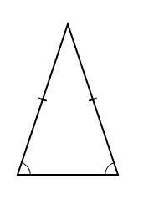
Equilateral triangles have three sides with the same length. Each interior angle of an equilateral triangle measures 60°.
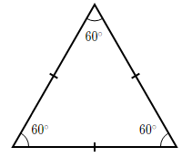

Quadrilaterals
Quadrilaterals are polygons with four sides and four interior angles.
Parallelograms are quadrilaterals with two pairs of parallel sides and two pairs of angles with the same measure. The opposite sides have the same length, and adjacent angles are
supplementary
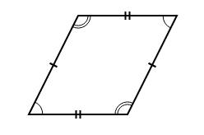
Rectangles are parallelograms with four 90° angles. The adjacent sides are perpendicular. While all rectangles are parallelograms, not all parallelograms are rectangles.
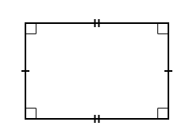
Squares are parallelograms with four sides of equal length and four 90^\circ90∘90, degrees angles. While all squares are both rectangles and parallelograms, not all parallelograms are squares and not all rectangles are squares.
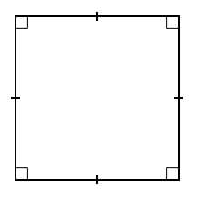
Exercices :
- If a square is divided into 4 identical areas, which of the following could be the shapes of these areas?
- Triangles
- Rectangles
- Squares
- Which of the following statements must be true for a square?
- Opposite sides have equal length.
- Adjacent angles have the same measure.
- Adjacent sides are perpendicular.

